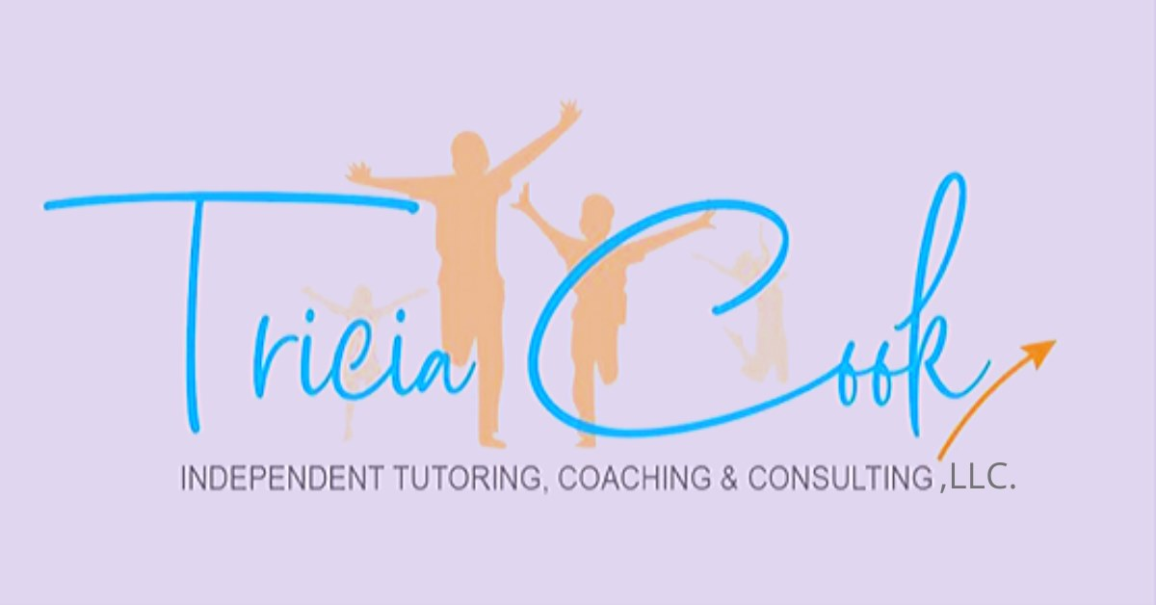
Part I Nurture Their Nature

Introduction
After over twenty years of being in education, I provide tutoring, consulting, and coaching on dyslexia and other neurodevelopmental differences. Over the last 15 years, I’ve observed an increasing amount of behavioral, sensorial, cognitive, physical, mental, and spiritual difficulties and differences along with an increased number of children being medicated and misdiagnosed; Therefore, I developed a revolutionary program that includes an evaluation that “looks at the whole child.” I work with all stakeholders on constructive engagement when learning based on my student “whole child” observation(s) inspired by Maria Montessori, Neville Lancelot Goddard, Benjamin Bloom, Peter Levine, Conrad E. and Cohen B., Dr. J. Puleo & Dr. L. Horowitz, Howard Garner, Dr. Bradley Nelsen, Hans Berger, Jean Piaget, Grolnick, W. & Kurowski, C. and Erik Erickson. I have also developed a revolutionary training/intervention program for people with unique learning and neurodifferences. This program is based on my own inductive reasoning and a detective sense contributed to my own gift of dyslexia, countless hours of student observations, neruopedagogy, holism, neuroscientific, educational research and studies along with my perpetual care for children.

My motivation is to inform schools, organizations, and their families, who consider themselves weak or weary with challenges of nerurodiversity and learning uniquenesses, by implementing and working with teachers, specialist, and families through social media, courses/speaking engagements, book sales, coaching/consulting, and outreach all with my internationally recognized ELBERT™ (view program HERE)! As well as, I would like to share I little about myself and how I can help you by consulting and/or training! I have dyslexia myself and struggled with anger/shame due to LD (view My Story Of Dyslexia: HERE); I’ve been a Dyslexia Interventionist since 2015; I have been tutoring since 2001; I have been working with students of all ages (literally 18 months-81 years old), It has been my desire to work with the neurodiverse also since 2001 and I have heavily studied learning differences since around 2004; studied human development and education- even developed an neuropedagogy based on educational, neuroscience research; I’ve earned several certifications to help tutor and teach those with learning differences such as the following: State-Certified Reading Specialist (P-12); M. Ed., Degree in Secondary Education; Orton- Gillingham AGOPE AA Tutor Certified; Highly Qualified Status in Reading and Early Childhood Education; AMS Montessori Toddler Certified; Accredited Status 10 Program- 210 Credit Hours of Speech, Language Pathology & Bachelors; State-Teacher Certified in Early Childhood Education (P-3).
As you know, schools, organizations, and families are desperately looking for an effective, alternative type of affordable, multi-sensory, handshakes-on, and interesting instruction and evaluation for learning differences; especially, families here in Alabama with our low literacy rates in varying low-high socioeconomic backgrounds. I’m now going to a school near you!! As you may know, literacy (writing, reading and speaking) is key in growing their identity holistically through the spirit, soul and body. Therefore, I’m especially seeking to help Title I-V schools, who have had graduated students—- who are possible illiterate and/or suffer from learning and behavioral-mental challenges, now living in jail, considered to have low-end jobs, living in impoverished conditions, and have poor opportunities to flourish. They might be weak and weary, but they are truly divine. My ELBERT™ program will hopefully help them to heal and consider themselves as divine, increase their trust, connection and love for others and God, hopefully get them out of unwarranted situations by developing their lives’ purpose, and change their DNA! This desire has prompted me to share more about my reasoning for my ELBERT™ program. With my new program, I am searching to tell my story/testimony of dyslexia by coaching, training and consulting opportunities by inform schools, organizations, and their families. I’m also interested in connecting with professionals all over the world with common interests related to alternative and holistic education such as: explicit instruction, neurodiversity awareness, epigenetics, neuropedagogy, self-directed neuroplasticity, literacy tutoring, learning differences, positive mindset and positive learning environments. What I’m presenting to you guys with an ‘alternative perspective’ not a typical one, because I’ve definitely have a divergent mind not atypical one personally. I’m not your traditional academia type educator (even though my extensive resume says otherwise- see HERE) in the least due to my experiences with growing up neurodifference. So please do not hesitate to contact me. I’m online but willing to travel.

My book Nurture Their Nature looks at the “whole child” and complete learning differences including the nature and nurture of the neurodifference. to dispel learning apathy to be successfully, we need to look at the “whole child” and their neuro-symatic learning functions. For learning apathy which includes motivation and resilience (meaning) to be successful, you need to have a strong cognitive, behavioral, and affective-spiritual components which include the following: a healthy and functional physiological, sensory-motor systems (thymus) which is our exteroception and interoception (“our senses'') including our sensory system (especially visual and auditory) along with central and peripheral nervous systems- vagus nerve which is regullates the RAS & ACC/HPA, Pons (parts of the brain), and biofield (including electromagnetic field, internal chakras); neuroplasticity and IQ; positive perceptions specifically strength and empathy (along with reduced perceptions of anger and shame); hormones released such as serotonin, dopamine, cortisol along with autonomy (for meaning, speed processing, and long-term memory) and attunement (for meaning & motivation, speed processing, and short-term memory). Therefore, when learning difficulties occur, our neurobiology (neurosystems), central and peripheral nervous system, complete chakra, and electromagnetic systems are all dysfunctioning or dysregulating simultaneously and individually at different degrees and causing abnormal neuroplasticity. Our goal is for ALL our systems and senses to function equalized, activated, and balanced. With a functional system, the child can trust themselves through spiritual mindset with self-directed neuroplasticity through ABC’s and gain God awareness (eventually unity) through PYAM.
For learning to be successful, we need to look at the “whole child” and their neuro-symatic learning functions. -Tricia Cook
Again, speaking of the “whole child”- you need to examine every aspect of their learning, not just the end goal or result which is literacy and their appropriate learning behavior. Now, we know epigenetics relating to learning influences of generational anger and shame have the ability of being healed and determines which genes will be expressed and how their own systems will function. The main goal is to heal our very own DNA holistically through exercises and activities which block or ease the production of specific inflammatory proteins (toxicity) excreted by the gut-brain axis, decreasing biochemical reactions that happen between the Pineal, Pituitary, Adrenal & Carotid Glands along with by activating and aligning the Thymus (via vagus nerve chakra) and Pons, RAS & ACC/HPA (alta major and soma chakras) causing decrease in deficiencies while regulating our own biofields (including electromagnetic fields). This is the divine stamp where you are regulated and experiencing harmony, honor, wisdom, and becoming devoted to your purpose. You need to again, speaking of the “whole child”- you need to examine every aspect of their learning, not just the end goal or result which is literacy and their appropriate learning behavior.
Ways to look at neurodifferences holistically: observe and take observational notes on the child…50% Nature- 50% Nurture (focus on epigenetics and spiritual mindset along with self-directed neuroplasticity): What Is Epigenetics? [Retrieved from The Answer to the Nature vs. Nurture Debate.” Center on the Developing Child at Harvard University, 30 Oct. 2020, developingchild.harvard.edu/resources/what-is-epigenetics-and-how-does-it-relate-to-child-development/.]
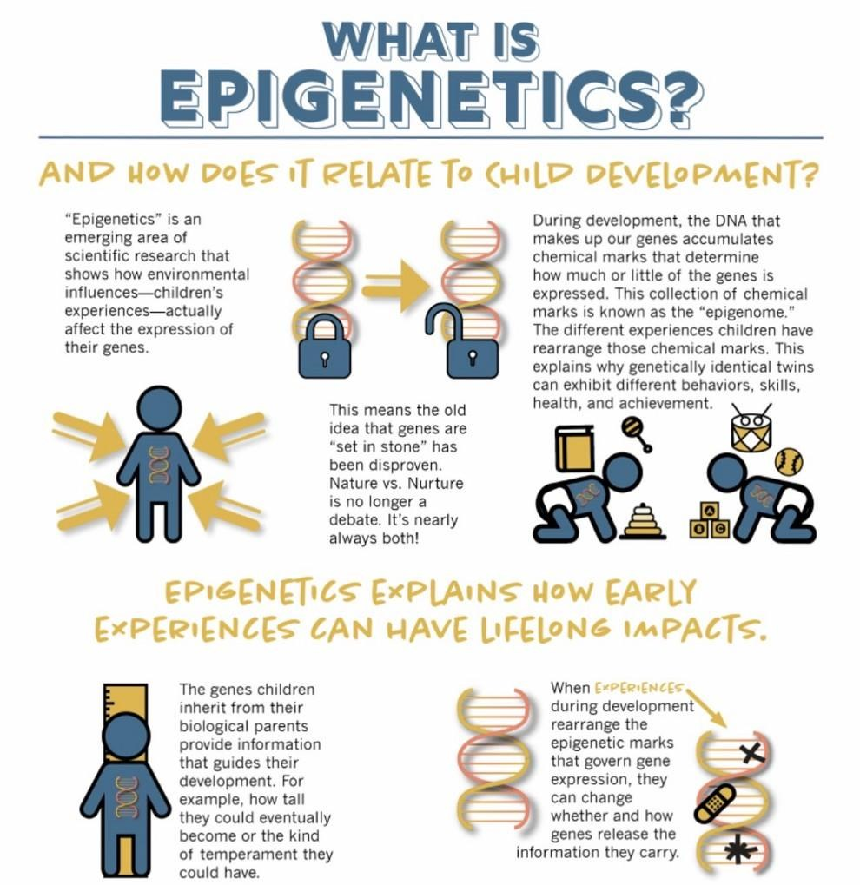
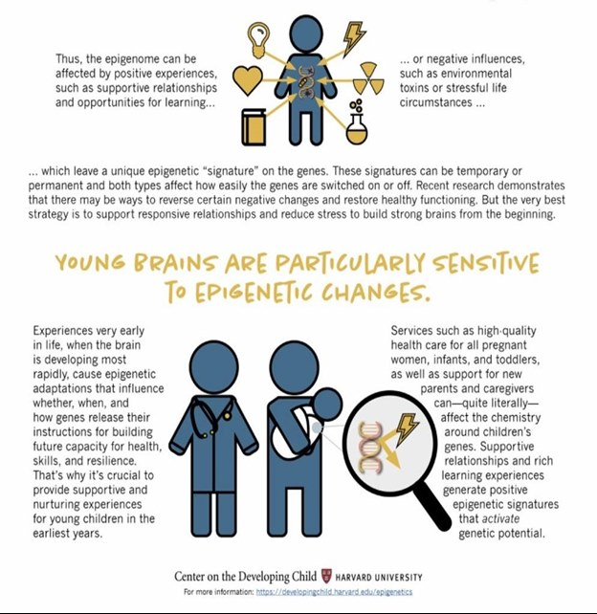
DISCLAIMER: This communication may contain privileged and/or confidential information. It is intended solely for the use of the addressee. If you are not the intended recipient, you are strictly prohibited from disclosing, copying, distributing or using any of this information. If you received this communication in error, please contact the sender immediately and destroy the material in its entirety, whether electronic or hard copy. This evaluation, program, and suggestions are not to be substituted for professional Medical advice. They should not be used to diagnose or prescribe. Tricia is not a doctor.

Nature

Chapter 1 The Body
Nature- is the maturation of the brain and body; for the purpose of survival, it’s the ability to perceive, give meaning, learn, and act including motivation and resilience of our very own environments (patterns first). Speaking of the “whole child”- the vagus nerve connects the brainstem to the body. It also connects and aligns the chakras, Pons, RAS & ACC/HPA and thymus including their own biofield (including electromagnetic field). This vagal balance allows the brain stem to receive the information (formulating patterned neural connections) from the environment, the midbrain to monitor and receive information (firing pattern of brain nerve cells in a network), and the frontal lobe to perceive the universal emotions which are the following: anger, strength, joy, bliss, shame, empathy, courage, compassion, and harmony. Executive functioning involves logic through analysis or evaluation; initially, the thymus is where the mind deems how important based on cellular memory (what or why). Then onto the frontal lobe where the “why” is based on context cues (evaluation) and the “what” is based on recursive aspects (analysis). The vagus nerve controls vagal balance and the executive functioning system (via the thymus- vagus nerve chakra). The thymus including the vagus nerve can be deactivated, hyperactivated, hypoactive, underdeveloped, or variably then going inactive in children (adults-too); therefore, releasing specific inflammatory proteins at the gut-brain axis which can be toxic to the triune brain [Retrieved from Sunny Sea Gold Updated January 27, 2021. “Here’s How the Brain Makes Memories-and What You Can Do to Keep Your Mind Sharp.” Health.com, www-health-com.cdn.ampproject.org/c/s/www.health.com/mind-body/brain-memory-healthy-mind?amp=true].

Eliminating Negative Thoughts
In the field of psychology, emotions are not just our feelings as some may think. Emotions are our feelings, thoughts, ideas, perceptions, physical sensations and involve the senses and their systems all for which start in the mind. They create what we call mindset- needing a calm mindset for equanimity is key. Our God mindset regulates every love or fear experience we have and our very purpose of being here on earth. The emotions need to be honored, especially anger and shame. The ‘theory of mind’ is an assessment of an individual human's degree of capacity for empathy and strength; as well as our understanding of ourselves and others have a mind too. Where the mind is located has been a continuous debate- I propose that the mind at least begin in our very own thymus. The thymus is the center of both our higher and lower self. It is the epicenter of a vagus nerve highway including the interchanges from our gut-brain axis, to our Pons, RAS including ACC and HPA (both housed with-in the brain) which all control every system in the human body. The thymus can be overtaken by love or fear- it’s where our consciousness and super consciousness (consciousness and subconscious conjoin in unity) begins and ends.
The attitude depends on the student finding motivation and meaning for their learning. One's attitude for learning makes for a make or break type learning. -Tricia Cook
In the field of child-psychology, “Every attitude has three components that are represented in what is called the ABC model of attitudes: A for affective, B for behavioral, and C for cognitive. Although every attitude has these three components, any particular attitude can be based on one component more than another (Study.com 2020).” The naming of the word attitude as it relates to students learning can give someone a negative perception; parents ask me all the time, “can you help me with my child’s attitude”. The attitude one has for learning makes for a make or break type learning. I observe kids all the time with Responsive System Dysfunction (RSD) which means it is hard to find meaning and motivation for learning. When your child is learning under stress, fear, and having RDS, they are learning from their mental or emotional bodies, primarily with a Sympathetic (anger) Functional System which is a hyper-processing dysfunction and Parasympathetic (shame) Functional System Dysfunction which is a hypo-processing dysfunction or both anger/shame which is a Total Functional Dominance System which is a varied hyper-, hypo- dysfunction of the RAS (Rectangular Activation System). This hyper-, hypo- and varied dominance affects the “whole child”.

Another Recent Study uncovers the “Tendency for Interpersonal Victimhood”: A new personality construct has been defined that describes people who persistently see themselves as victims within interpersonal conflicts.
The research was published in Personality and Individual Differences: https://www.psypost.org/2020/12/researchers-identify-a-new-personality-construct-that-describes-the-tendency-to-see-oneself-as-a-victim-58753
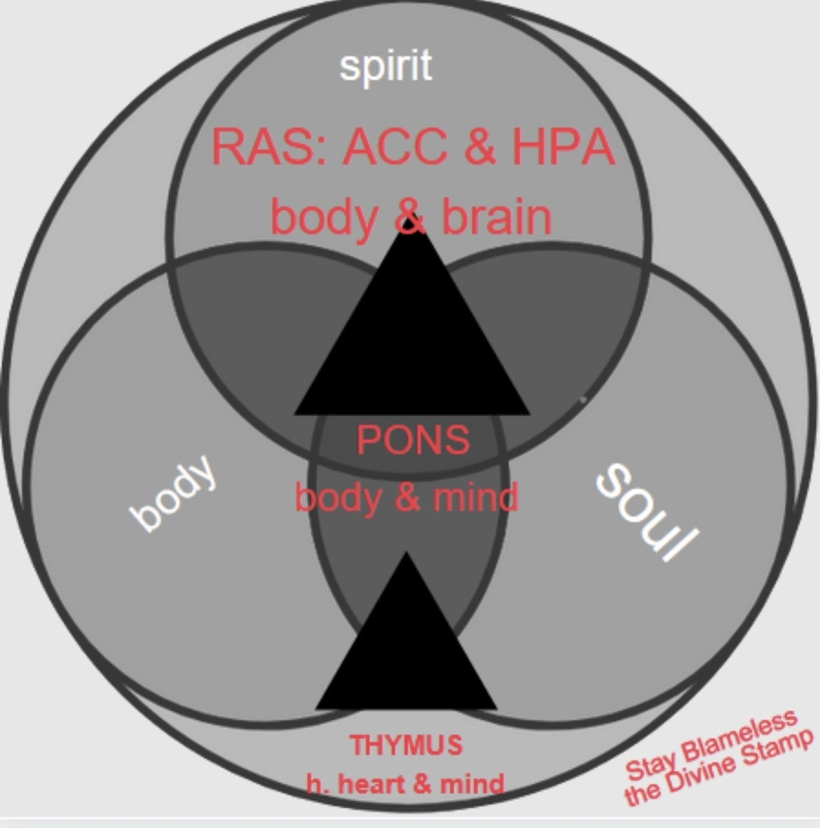
1 - A Blameless and Pure Life Via Trusting The Thymus (Mind)
BY HEALING OUR VERY OWN [LEARNING] DIFFERENCE

“My ELBERT develops connection, trust, and love by instilling curiosity, autonomy, and attunement in our students.” by Tricia Cook
In your relationships with one another, have the same mindset as Christ Jesus. Phillippians 2:5

THE BODY INCLUDES: HEART, BRAIN & MIND

Mind You Again: The Heart
Specifically, the mental body is anger brain dominant and perceives in the heart everything related to learning with anger. The emotional body is shame brain dominant and perceives in the heart everything related to learning with shame. According to my good friend, Tom Heintz (An Emotional Code Practitioner-Creator of The Body Code) references Christine H., MS, LMHC (Hammond 2018), ‘Anxiety [anger and shame] is one emotion that can be passed down from one generation to the next. Also, there are 10 emotions that can also be inherited through family trauma, parental modeling, and/or abusive behaviors.’ For those who struggle with sensory triggers and learning stressors, like when experiencing reading or writing, these negatively perceived and filtered experiences with anger and shame, can cause a trauma type of developmental anxiety and sometimes even depression. Heintz (2020) also refers to this following excerpt from Christine Hammond, MS, LMHC (2018):
- Anger – There are three main types of unhealthy anger: aggressive anger, passive-aggressive anger [shame], and suppressive anger [hatred- not kids usually] – all of which can negatively affect a child. For example, if a parent is aggressively angry by yelling, their child might grow up to mimic the same behavior or learn to redirect it into their own manifestation of anger.
- Shame – Hearing words from parents such as, “You will never be good enough,” or “You are stupid,” attack the heart of who a person is. Sadly enough, shaming tactics are pervasive in hyper-religious homes where a child is told that they have to live up to some unrealistic standard and very frequently are practiced by the child on others once they have been exposed to such treatment” [Generational Healing: tom@thebodyemotions.com; accessed on 2/19/20 “10 Emotions That Can Be Inherited.” The Body Emotions, 21 Apr. 2020, thebodyemotions.com/10-emotions-that-can-be-inherited/].
In 2018, I created My ELBERT™ Responsive System Dysfunction (RSD) Checklist which is Functional System Dominance Checklist. I have found in over 4 dozen students what I always knew; that they develop anger first, if not given a healthy, safe, and supportive environment for their anger. Also, anger can develop into shame. Then, the shame will be more dominant. ELBERT™ sysm/para checklist and resources are important for those working with neurodifferences because shame is harder to address than anger. Shame is the defense for anger and survival of some people. Some people though are less susceptible to shame and remain in anger. I have found more times than not where just anger has been marked; especially in younger students. Note: if anger and shame are not addressed at a young age, it can turn into hatred and grief. Also, anger appears anxiously (hyper activity) and shame appears sadly depressed (hypo activity). Together with both anger and shame, someone can appear anxious and sad. With shame being the hardest, their body may appear calm but internally their mind can be ruminating on negative thoughts, feelings, ideas and emotions which can be hard to know unless your child shares them with someone. This is why the checklist and interview is so important. I interview the students and their parents (teachers too preferably) where an [x] means most of the time in their learning environment and a [/] means some of the time in their learning environment (see image 1.0).
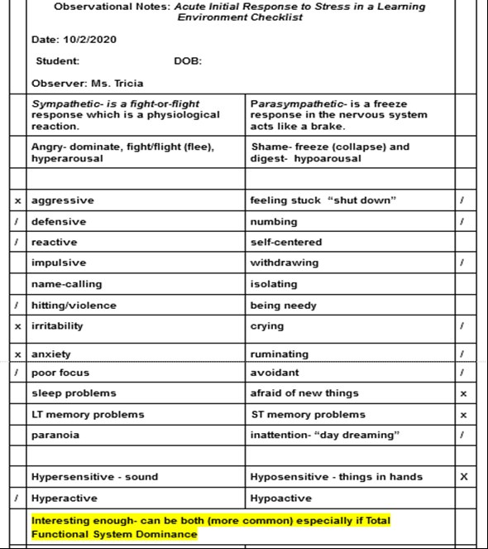
2 - Image 1.0 The ELBERT™ Functional System Dominance Checklist illustration
“Neuroplasticity allows the neurons (nerve cells) in the brain to compensate for injury and disease and to adjust their activities in response to new situations or to changes in their environment” (Definition of Neuroplasticity, 2020). Also, I’m needing to mention developmental trauma and learning something new, switing content and context frequently!!
When a child with neurodifferences is learning something new or stressful, if mindset is perceived with anger (SFD), we can observe lessened neuroplasticity of the midbrain (right lobe) and constant speed shifting (accelerated or and varied) of the prefrontal cortex, frontal lobe along with midbrain (left lobe) and emotional disorders with long term memory problems. Likewise, if the mindset is perceived with shame (PFD), we can observe lessened neuroplasticity of the prefrontal cortex, frontal lobe along with midbrain (left lobe) and constant speed shifting (slow or and varied) of the midbrain (right lobe) along with more executive functioning issues and short term memory problems or midbrain. We can attribute this constant speed shifting to the common problems of poor neuroplasticity. Likewise, the lacking a self-directed neuroplasticity such as positive mindset such as mind trusting qualities of belief: I AM worthy (autonomy) and I AM enough (attunement), feeling safe and secure in their environment.

There are several other factors for successfully expelling learning apathy such as with gaining resilience (meaning), and motivation such as: sleep, diet, health and wellness, physical activity (body), regulation of vagus nerve (soul- body connection), sometimes even the spirit-soul-body connection (much older teens), gratitude including love of self and others (heart-connection). Also, the environment that most of us live in today causing sensory overload along consistently multi-tasking and/or context-switching (handling 2 or more tasks at the same time) especially in this complex, non-connected (yet, connected), neurotoxic and EMF toxic infused environment- ALL decreasing our very own electromagnetism and vagal tone.

Mind You Again: The Brain
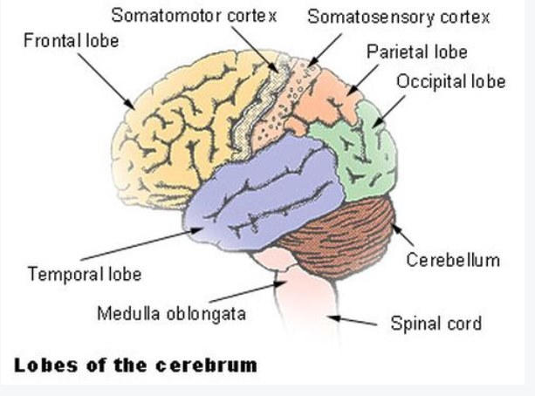
3 - CHAPTER 2
Specifically, if the vagal system is comprised including the following areas of the brain:
Anterior Cingulate Cortex (ACC) and Vibrating the Alta Major Chakra
The Cinguate Gyrus (CAN)- is a large arch-like lobe in the center of the inner brain that is a part of the limbic system; it houses the organs and their interactions constitute the Anterior Cingulate Cortex (ACC-shame) and the main function of this area of the brain functions to process conscious emotional experience and the parasympathetic nervous system (right side). The ACC plays an important part of conscious reappraisal of emotions such as shame/empathy and anger/strength for the ARAS). Note: The amygdala, bulb at bottom not shown in pic.., is where The Cinguate Gyrus (CAN) first receives perceptions from the mind via the thymus, via the peripheral cranial/CNS nerves, then onto the ACC. A hyper-, hypo- amygdala works harder and the VACC can get dysregulated (shame mainly).
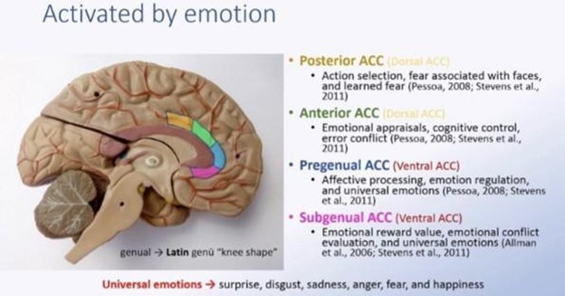
4 - 2.0 ACC & Cinguate Gyrus (CAN) illustration

NOTE: (HPA) Hypothalamic–Pituitary–Adrenal and Vibrating the Soma Chakra
The hypothalamic–pituitary–adrenal axis is a complex set of direct influences and feedback interactions among three components: the hypothalamus, the pituitary gland, and the adrenal glands associated with the soma chakra and anger. These organs and their interactions constitute the HPA (anger) axis, a major neuroendocrine system that controls reactions to stress and regulates many body processes, including digestion, the immune system and the sympathetic nervous system (frontal lobe/left side). Note: Like above, the amygdala, bulb at bottom not shown in pic.., is where The Cinguate Gyrus (CAN) first receives perceptions from the mind (cellular memory- anger mainly) via the thymus, via the peripheral cranial/CNS nerves, then onto the ACC. [Retrieved from The Brain Network Driving Changes in Consciousness —FeaturedNeuroscience·December 28, 2020, et al. “The Brain Network Driving Changes in Consciousness.” Neuroscience News, 28 Dec. 2020, neurosciencenews.com/consciousness-brain-network-17491/).]
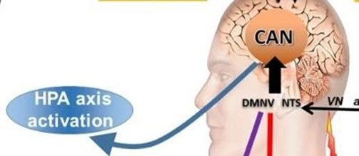
5 - 2.1 HPA illustration

Vagus Nerve and Vibrating the Soma and Alta Major Chakra
The vagus nerve- is one of the cranial nerves that connect the brain to the body. More specifically, it’s the connection between the brain and the gastrointestinal tract. Likewise, the vagus nerve has two bunches of sensory nerve cell bodies, and it connects the brainstem to the body and vagal nerves carry somatic and visceral afferents that can alter the activity of the brainstem at the point of the reticular activation centers (RAS). Remember the RAS & ACC (shame)/HPA (anger) also allows the brain to monitor and receive information about several of the body’s different functions and matters of the mind including the perceptions and filters of the parasympathetic (shame), sympathetic (anger) & total (anger/shame) response system during stress such as reading. When you activate the chakras (major 8 and soma/alta major- HPA (anger)/ACC(shame)) and normalize, balance the vagal tone and electromagnetic field, it will stop the “epigenome” which are again the collection of chemicals markers (focus: inherently dyslexia). This interruption will allow the body to then calm, be healthy, resilient, gain positive attitudes (joy, bliss, and happiness) and make learning more pleasurable and effective; therefore, also the Reticular Activating System (RAS) needs to be activated via the vagus nerve (thymus- vagus nerve chakra). The ascending reticular activating system (ARAS) itself is on the cerebral cortex and is responsible for the achievement of super consciousness (higher transpersonal self) . Note: The ARAS doesn’t fully develop in the brain until variably, around the ages 21–24 years old (Fowler, J.W. 1998). [“Fowler Faith Stages.” Encyclopedia of the Sciences of Learning, 2012, pp. 1323–1323., doi:10.1007/978-1-4419-1428-6_].
“Disorders of consciousness (DOC) represent a big and multi-perspective challenge of contemporary clinical neuroscience. First, measuring consciousness and identifying the mechanisms of unconsciousness are still open issues that neuroimaging and neurophysiology are trying to answer with different and complementary approaches.” [Retrieved from https://www.mdpi.com/journal/jcm/special_issues/Brain_Networks_Disorders_Consciousness]
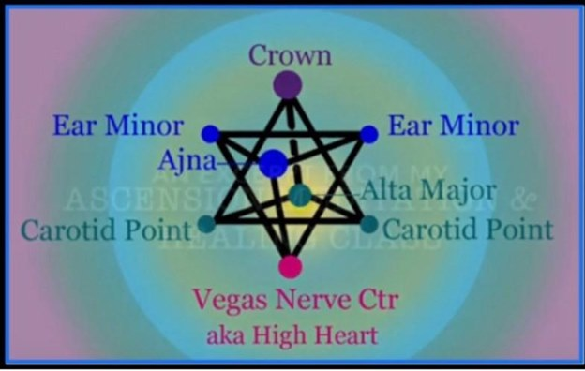
6 - 2.2 Vagus Nerve Chakra (Upper Heart Chakra-Thymus) illustration Note: includes Soma and Alta Major chakras
Remember the vagus nerve also connects the brainstem to the body. The vagus nerve also is connected to the eight chakras via RAS & ACC (shame)/HPA (anger)- by activating the eight chakras including the soma/alta major via the vagus nerve, it can continue doing its job of helping us connect our brain stem to the body; hence, regulating our biofield (including electromagnetic fields). One of the major goals of the paper and program includes holistic alternatives and activities for equanimity and to block or ease the production of specific inflammatory proteins and chemicals (toxicity) excreted at the gut-brain axis via the vagus nerve, align and balance the eight chakras (soma/alta major also) including Pons, RAS and ACC (shame)/HPA (anger) areas of the brain to regulate our own biofields aka senses (including electromagnetic fields). Also, for the thymus (vagus nerve chakra) to become regulated and balanced.

Corpus Callosum
Corpus callosum- links both hemispheres and to varying degrees. Hence students might have a lateral cognitive dominance of the functioning system- the students with the right-hemisphere dominance have Parasympathetic Functional System Dominance (PFD) and might have dysphonetic dyslexia because language and analysis (break down category and sequencing) which is a left-hemisphere task: therefore, students with right-hemisphere dominance might have high functioning autism, can have language deficits such as dsyphonetic (auditory) dyslexia.
Unilateral Neglect (or Hemispatial Neglect)/Total Functioning System Dominance (TFD)- student might have high-functioning autism along with other learning differences (below). Someone prominent in right-brain (ACC) has an unawareness of objects to one side of the body or personal space. In severe cases, a side can be completely ignored when carrying out certain tasks and everyday functions such as writing so may have dysgraphia. But another important brain function is controlled by either the right side of your brain or the left side of your brain depending on your handedness.
Sympathetic Functioning System Dominance (SFD) student has total (see below) or left corpus callosum dysfunction then having a total right or left-lateral hemisphere dominance (HPA), evaluation (specifically color, shape, size & dimension) is a right-hemisphere task; those with a Sympathetic Functioning System Dominance (SFD) therefore, might have autism, Irlen Syndrome, and dsyeidetic (visual) dyslexia.
Unilateral Neglect (or Hemispatial Neglect)/Total Functioning System Dominance (TFD)- students might have autism (lower functioning) along with other learning differences (below). Someone with dominant frontal lobe or the (left) dominant temporal lobe (SFD) can cause a condition called aphasia, which is a serious disturbance of speech and communication.
Functional Disconnection/ Complete Functioning System Dominance Syndrome when the short-term memory aka “working memory” is not equalized, then the information being led by the Corpus Colosseum to the frontal lobe for executive functioning becomes deficient- when in adults hatred and grief are invoved. Whether the Corpus Colosseum is underdeveloped or deficient in it’s development for example: there can be blockage, protein folding, insufficient synapse development (premature pruning), poor fluid to transfer synapse message, etc. Also, if the Corpus Colosseum, the “short term memory” is compromised this is also known as Mixed Brain Dominance or dysphasia and forms of autism.

Mind You Again: The Mind
With just a Sympathetic Functional System Dominance (SFD), they perceive in the mind everything with anger during stressful experiences. When they have a Parasympathetic Functional System Dominance (PFD), in the mind, they filter and attune themselves to everything with shame. When we have both anger and shame in the mind (see child sample above), this is called a Total Learning System Dysfunction (TLSD) which creates: this creates almost complete soul-body disconnect (dysregulation) due to constant learning aka cognitive speed shifting (hyper-. hypo-, and varied) which tires out the brain’s (RAS) Rectangular Activation System (chakras 6-8th including soma and alta-major chakras), Pons (crown chakra), and Thymus (vagus nerve chakra) much quicker than the aligned and balanced learning brain and body which, in turn, lessens neuroplasticity. When our very own DNA generationally predispositions with dysfunctions of the Rectangular Activation System, Pons, and Thymus and for learning differences (anger and shame predispositions), ALL our systems and senses can have any dysfunctions, and therefore, we can actually have body-soul disconnection in the mind!

Mind you again, learning apathy is complicated and that the spirit-soul-body/connection-trust-love disconnection causes maladjustment and belonging in this world. Don’t worry, our spirit, soul, and body connection can also be complicated to a point, if we understand that we are love and not meant for fear. Think about it this way, when your child has a Hypo or Hyper, Total Responsive System Dysfunction (RSD), their learning decreases due to disconnections to others-themselves, soul-body disconnection of consciousness, perceptions of anger/shame along with assimilation (meaning and motivation) of those perceptions. Sadly, the students who have RSD dysfunctions, they can become labeled Learning Disabled amongst other labels. Therefore, they are not learning effectively, cognitively, or behaviorally on a conscious level nor helped in a way that is revolutionary nor effective.

Chapter 3 Quantum-self: There are three forms body, soul, & spirit

The Soul- the high heart and mind
- People with a neurodifference (approx. 23% of population) learn from Pathos to Ethose All "Atypical" People Learn Ethos to Pathos--------but there’s a missing third component for ALL LEARNING FOR EVERYONE The Authentic Self (thymus):
(RAS- HPA & ACC) The Body & Breath of Jesus (1st-3rd chakras)

- The PATHOS- "the why" is the Pons (body & mind = midbrain) which is a small part of the brain above the pons that integrates sensory information and relays it upward (RAS). Similar to the RAS, it is responsible for arousal (hyper-, hypo-, and varied) and plays a role in mood. In terms of long–term physiological changes, it is also associated with long-term memory- it's the past and the future. This is also where dreams are centered based on our thymus and what we focus on or need healing to become pure and blameless. It is where our dreams come into our reality and then onto fruition and grief and hatred can prohibit. Correlated with chakras 1st-8th so needing courage and compassion.

(PONS) The Heart & Breath of Holy Ghost (4-6th chakras)

- The ETHOS- "the what" is the RAS= HPA & ACC (body & brain= brain stem) processing side and short-term memory- it's the present and the arousal of the limbic cortex such as: ACC- amygdala, and the hippocampus. It is where our dreams come into our reality and then onto fruition, need healing to have grace and mercy and shame or fear can prohibit. Correlated with chakras 6–8th so needing empathy.
(THYMUS) The Mind & Soul-Spirit Connection of God (7-12th chakras)

- THE Authentic Self (the true question/answer) is the Thymus (high heart & mind= soul) a connection of perception between all affective and behavioral cognitive experiences on a cellular level (cellular memory) including the mainstream universal emotions of anger, strength, joy, bliss, shame, courage, compassion, and harmony and relays it upward (PONS). It’s also where you can find the “imagination” and "intelligence" that lies within all of us of God’s Will. This is where the God's mind creates our purpose by filtering, interpreting our world and experiences which in turn creates our dreams into reality of miracles and blessings and Nothing Can Prohibit IF RECEIVED GOD. Correlated with chakra 9-12 and all the rest of the chakras.
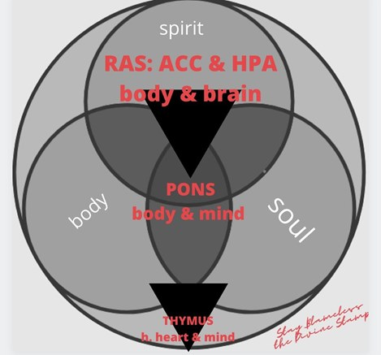
7 - NOTE: A Total Learning System Dysfunction (TLSD) and Dysregulated and Dysfunctional System Responsive System Dysfunction (RSD) works in a downward effect from RAS-PONS-THYMUS:
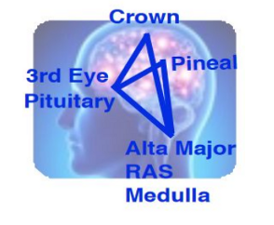
8 - 2.3 RAS Rectangular Activation System Note: includes Soma and Alta Major Chakras illustration
Vagus Nerve & RAS Vibrating Alta Major Chakra (*aka God Awareness Chakra)
The Reticular Activating System (RAS)- is a network of neurons (hyper-, hypo-, or, varied) located in the brain stem that project anteriorly to the hypothalamus to mediate behavior such as sleep, memory, and learning; as well as, both posteriorly to the thalamus and directly to the cortex for activation of awake, desynchronized cortical EEG patterns. It is holistically and spiritually known from being a center “where we can create our own reality” whether positive, negative or neutral. Knowing: What we focus on in our mind (thymus), pons (dream center) then comes to fruition here in our RAS.
The ACC (see top)- is part of RAS (Pineal Gland, Pituitary Gland) associated with the alta major chakra and shame.
HPA (see top)-(Hypothalamic–Pituitary–Adrenal Axis) associated with the soma chakra and anger.
Both are associated with the thymus chakra aka vagus nerve chakra.
Note: Important RAS info. includes the following excerpt... ‘The RAS is said to be the gas pedal [slow (hypo-), accelerate (hyper-) or varied cognitive speed processing] that ignites the diencephalon (the hypothalamus and thalamus) as well as the cortical areas [where all long-term memory/storage takes place] of the brain’ (Petty 1996).

Pons
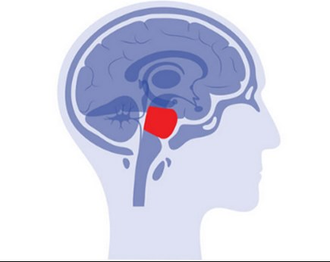
9 - image 4.1 Pons Illustration works with RAS (*aka God Awareness Chakra)
The pons integrates both the medulla oblongata and the thalamus (NOTE: the importance of conscious reappraisal of emotions (emotional reappraisal) such as shame/empathy and anger/strength for the ARAS). In the thalamus, students can have a slow (hypo-), accelerated (hyper-) or varied processing and they have a problem with sensory integration disorders (corollary discharge) and emotional intensity or insensitivity with their neurodifference. The Pons, like the RAS, is responsible for arousal (hyper-, hypo- and varied). Plus, the pons connects areas of the brain that controls autonomic functions (parasympathetic (shame) /sympathetic (anger)): Acting or occurring involuntarily, without conscious control, in the somatic nervous system such as sleep and histamine inhibitors: The part of the peripheral nervous system that transmits signals from the central nervous system to skeletal muscles, and from receptors of external stimuli such as mediating sight, hearing, and touch and movement including speaking with conscious control (RAS-alta major chakra, crown chakra specifically via the thymus (Vagus Nerve Chakra)).

The pons controls our breath known as ‘life’. God gave us the ‘life’, so we can be the breath of God, leading a pure and blameless life. The pons just doesn’t serve to help the different lobes communicate but also is the veil of God. The pons area also contains the trapezoid body (RAS) where you are able to vocalize sounds. This allows us to sing, praise and speak, and share His word- Hallelujah.

Since the pons and the thymus (see below) as well as the RAS work together, Students with Sympathetic Functional System Dominance (SFD) can have problems “Seeing God” and “feeling worthy” (Aphantasia)- for God awareness they need circumstantial evidence or can go to extreme become ulta-religious constantly “breaking down” the Bible and religion or non-religious. Those with a Parasympathetic Functional System Dominance (PFD) have problems “Hearing God '' and “feeling enough”- for God awareness being calm in the mind- being present and ruminating on past/future a must. (PONS is addressed more in my ELBERT™ program: includes PYAM & RAS exercises body, breath, calm through prayer, yoga, affirmation, and meditation which connects us to God- see section below). Note: Students with Sympathetic Functional System Dominance (SFD) and Parasympathetic Functional System Dominance (PFD) have high allergy rates and sleep disturbances (see other complications below).
- Image 4.1a & 4.1b II Pons Axial Section and Peripheral Nervous System illustration which contains the Glia, also called glial cells or neuroglia, are non-neuronal cells in the central nervous system (brain and spinal cord) and the peripheral nervous system.

Note: For those with Dysphonetic (auditory) and Dsyeidetic (visual-surface) Dyslexia, the medial longitudinal fasciculus of the pons carries information about the direction that the eyes should move. It connects the cranial nerve nuclei III (Oculomotor nerve), IV (Trochlear nerve) and VI (Abducens nerve) together, and integrates movements directed by the gaze centers (frontal eye field) and information about head movement (from cranial VIII, Vestibulocochlear nerve- which The vestibulocochlear nerve is unusual in that it primarily consists of bipolar neurons. It is the nerve responsible for the special senses of hearing (via the cochlear nerve), and balance (via the vestibular nerve). Then the cochlea detects the magnitude and frequency of sound waves. Students with dyslexia have tendency for speech deficits and chronic ear infections, auditory as well as visual processing issues and sometimes balance and conflicting signals in the inner ear, eyes, and sensory receptors.
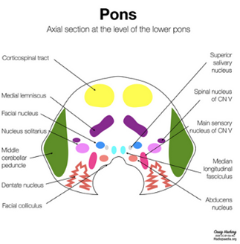
10 - Image 4.1a Pons Axial illustration
[Retrieved from
Google Image Result for Https://Biologydictionary.net/Wp-Content/Uploads/2020/11/Pons.jpg</i>, images.app.goo.gl/THSvxHLckja1]

The cranial nerves are controlled by the vagus of the peripheral nervous system. see 4.1b Peripheral Nervous System illustration (see the EM Field- The Senses and Chakras, Vagal Tone above)
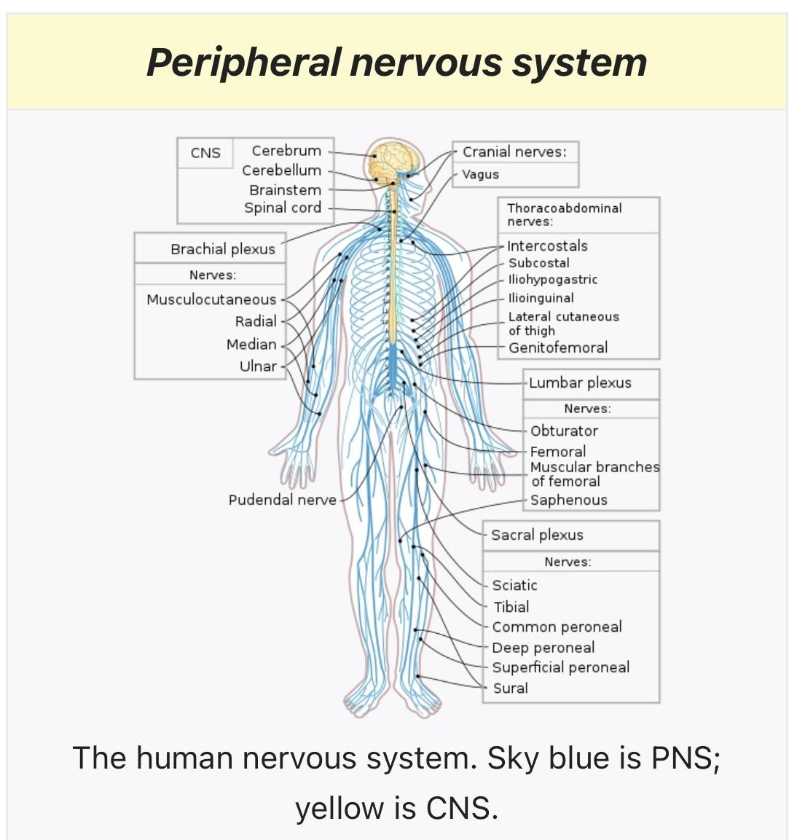
11 - 4.1b Peripheral Nervous System illustration

(peripheral sends info. to CNS- has effect on CNS as well as EM Field aka "the senses")

Thymus
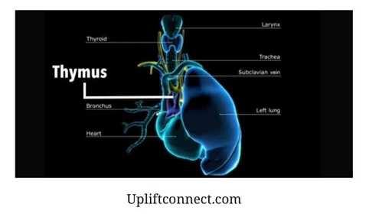
12 - image 4.2 thymus illustration works with RAS illustration

(has an effect to peripheral, Vagus Nerve, CNS- as well as EM Field aka "the senses")
Thymus (12th chakra and all chakras, high heart & mind)-Upper or Higher Heart Chakra (*aka God Unity Chakra, Ascension Chakra, Vagus Nerve Chakra). It is known as “the seat of the soul”, our Higher Intelligence & Imagination or "The Mind"- for the fact that it: holds a record of traumatic or painful events, dimensional to the subliminal content (see intelligence model below) and ancestral narration. High Heart Chakra, also called the ascended heart chakra, is connected with an organ: the thymus gland which before birth and throughout childhood, the thymus is instrumental in the production and maturation of T-lymphocytes or T cells, a specific type of white blood cell that protects the body from certain threats, including viruses and infections; It plays a role in immunity, autoimmunity, and aging (it’s basically our twin flame and fountain of youth).

It’s the subconscious mind because it interprets and filters our experiences and environment. It’s connection of perception between all affective, behavioral and cognitive experiences including the mainstream universal emotions of anger and shame on that of the pons, RAS (ARAS), vagus nerve and gut brain axis. It’s the internal fire [sacred fire] that gives us our purpose for God awareness (RAS) and unity (ARAS) intelligence (knowledge) connection. A healthy thymus gives us system regulation or unhealthy thymus system dysregulation (disintegration) of all our systems: contents, models and operations amongst our very own body, mind and spirit (see cubed model of intelligence illustration below).

New study of human brain tissue suggests clinical depression reduces the quantity of astrocyte cells in key regions
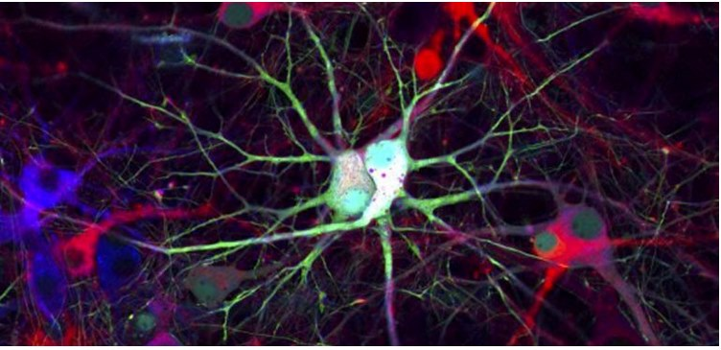
by Eric W. Dolan; May 4, 2021in Cognitive Science, Depression
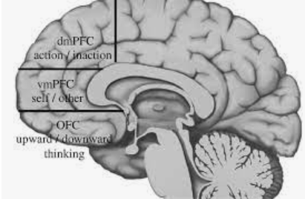
13 - dorsomedial prefrontal cortex controlled subconsciously by HPA (anger)
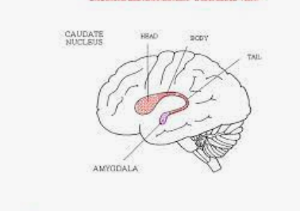
14 - dorsal caudate nucleus controlled subconsciously by ACC (shame)
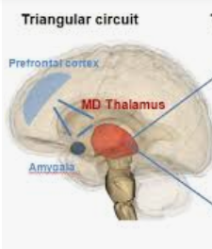
15 - mediodorsal thalamus controlled subconsciously by PONS (anger/shame)

“Now All Glory to God”
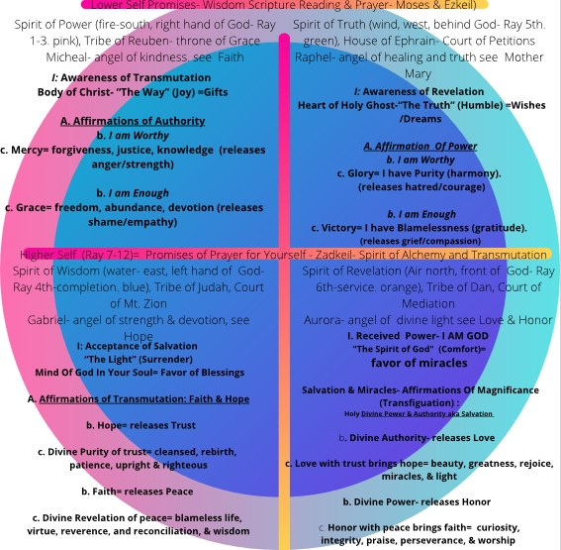
16 - https://www.canva.com/design/DAEVqAkCp9g/gOrsthOZMARP2nETjqhGvw/view
NEEDING TO BE ADDRESSED- Learning Differences including Our Electromagnetic System
All of our senses and corresponding systems give us vital information about our surroundings. Our EM field gives us “sense” included in our interoception and exteroception. Exteroception is sensitivity to stimuli originating outside of the body. sensitivity, sensitiveness, sensibility - (physiology) responsiveness to external stimuli; the faculty of sensation; "sensitivity to pain" visual modality, visual sense, vision, sight - the ability to see; the visual faculty. Interoception is the perception of sensations from inside the body and includes the perception of physical sensations related to internal organ function such as heartbeat, respiration, satiety, as well as the autonomic nervous system activity related to emotions (Vaitl 1996; Cameron 2001; Craig 2002; Barrett et al 1997). As well as, our EM and Torsion Field is "our senses" not what we think of as senses as the vehicle (ear, eyes, nose, mouth, skin, balance) that sends messages through our nerve endings, CNS and then to the brain. Our EM and Torsion Field, you will read more on later, includes our chakra system. These senses depend very closely on the thymus ‘our mind’ to make sense of our own world and experiences including relationships with others. Our senses give us our perceptions of our universal emotions, plus are we gonna live in fear or love. Our senses include our cellular memory and how we act. Again, for the divergent thinker it is where our mind consciousness makes our decisions not logic.

What is the law of conservation of energy? It states that energy can be converted in form, but not created or destroyed. I need for you to think about the universal emotions as energy that can be transformed or changed amongst being hereditarily passed down through generations and stored in the thymus (vagus nerve chakra) as well as translate into our very own DNA. Electromagnetic energy is part of our quantum-self; there are three forms of electromagnetic energy: visible light, infrared radiation, and radio waves. Let’s focus on 7 spheres of invisible light converted into visible light and ‘as you focus, so you are there in superconsciousness’ (see below) as 5 dimensional light- Glory and Victory.

In the same way, let your light shine before others, that they may see your good deeds [honor] and glorify your Father in heaven. Mathew 5:16
Affirmation of Hope: I am Honor. I have Light.
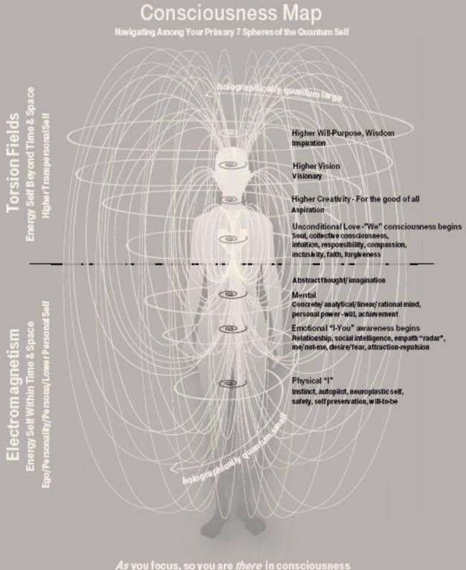
17 - 3.0 EM and Torsion Field illustration

The Senses Make Up Themselves & Their Corresponding Systems and Functions along with soul -body connections/ SOUL-SPIRIT CONNECTION
EM Field is our affective-spiritual components which include the following: a healthy and functional physiological, sensory-motor systems meaning our exteroception and interoception (“our senses'') including our sensory system (especially visual and auditory) along with central and peripheral nervous systems- which is regulated by RAS & ACC/HPA, Pons (parts of the brain), thymus and biofield (including electromagnetic field, internal chakras).

(RAS- HPA & ACC) The Body, Brain, & Breath of Jesus (1-3) Heals The Past
(PONS) The Heart & Breath of Holy Ghost (4-6) Counsels You Presently
(THYMUS) The Mind & Soul of God (7-12) The Future

* see image below The Trinity- THREE IN ONE Show (sight) & Tells You (hear) IN WORD ABOUT The Future So Pray
**Prayer works in threes with catechize (series of sequential questions to God)

Lower Personal Self: The Gifts
RAS ACC/HPA- Concrete Thought (conscious develops around age 2)
I: Awareness of Transmutation
Body of Christ- “The Way” (Joy) =Gifts
A. Affirmations of Authority
b. I am Worthy
c. Mercy= forgiveness, justice, knowledge, unconditional Love (releases anger/strength)
b. I am Enough
c. Grace= freedom, abundance, and devotion (releases shame/empathy)

Concrete Thought Cont. (conscious develops around age 2)
- Physical Self (chakras 1–3): anger/strength, joy, bliss, peace, shame/empathy
- Vestibular & Somatosensory Senses & Proprioception, Tactile Senses= RAS (chakras 6-8, body and brain)
- dysgraphia, dysphasia, cp, self-regulation, attention & executive functioning
God, what’s my (Your) reality? What are my gifts? (physical, emotional rational mind, personal power and will- Ego Center)

Including "the Senses":
The vestibular system is a sensory system that is responsible for providing our brain with information about motion, head position, and spatial orientation; it also is involved with motor functions that allow us to keep our balance, stabilize our head and body during movement, and maintain posture. Awareness of body balance and movement are monitored by the vestibular system. The vestibular senses (the sensations of body rotation and of gravitation and movement) arise in the inner ear; the sense organs are the hair cells that send out signals over the auditory nerve. The somatosensory system is the part of the sensory system concerned with the conscious perception of touch, pressure, pain, temperature, position, movement, and vibration, which arise from the muscles, joints, skin, and fascia. The tactile stimuli are detected by mechanoreceptors and produce sensations of touch and pressure. The proprioceptive system is located in our muscles and joints. It provides us with a sense of body awareness and detects/controls force and pressure. The proprioceptive system also has an important regulatory role in sensory processing as proprioceptive input can assist in controlling responses to sensory stimuli. The proprioceptive sense tells us about our body position. It is stimulated every time we move. Each time we use our muscles or stretch and bend our joints. Receptors for this sense are all over our body, deep within our joints and muscles. The tactile system refers to our sense of touch. Tactile doesn't just refer to our hands! The main way we perceive this input is through our skin, which has many receptors all over our bodies for all different kinds of sensations. Tactile sense related to touch, specifically the information received from varying pressure or vibration against the skin. Tactile sensation is considered a somatic sensation, meaning it originates at the surface of the body, rather than internally. (Somatic & Vestibular Issues See Pons including Basal Ganglia Below)

Lower Personal Self: The Dreams
PONS Abstract Thought (spiritual conscious begins develops around age 7, makes a jump at 12)
I: Awareness of Revelation
Heart of Holy Ghost-“The Truth” (Humble) =Wishes /Dreams
A. Affirmation Of Power
b. I am Worthy
c. Glory= I have Purity (harmony).
(releases hatred/courage)
b. I am Enough
c. Victory= I have Blamelessness (gratitude).
(releases grief/compassion)

Abstract Thought Cont. (spiritual conscious begins develops around age 7, makes a jump at 12)
- Mental Self (chakras 4–6, cognitive brain)
- Visual, Auditory Senses= Pons (chakras 9-11, body & mind- Note: only total functional dominance)
- dyslexia, higher functioning autism, oppositional and aggressive behavior
God, what are my (Your) dreams? What are my gifts? (creativity, visionary, aspiration, wisdom- Dream Center)
The visual system comprises the sensory organ (the eye) and parts of the central nervous system for visual processing. Again, remember the proprioception also referred to as kinaesthesia (or kinesthesia), is the sense of self-movement and body such as visual sense and the vestibular system, to create an overall representation of body position, movement, and acceleration. The auditory system is the sensory system for the sense of hearing. It includes both the sensory organs (the ears) and the auditory parts of the sensory system. The auditory parts help us to process sounds and language. Auditory sense is the ability to hear; the auditory faculty; auditory modality, sense of hearing, hearing. auditory system - the sensory system for hearing sense modality, sensory system, modality - a particular sense. (Somatic & Vestibular Issues See Pons including Basal Ganglia Below)

Including "the Senses":
Lower Personal Self: The Wishes
- Social/Emotional Self (chakras 6–8, soul mind)
- Olfactory & Gustatory Senses= Thymus (12th chakra, all chakras, high heart & mind)
- all learning difficulties, higher functioning autism, anxiety
God, what’s my (Your) purpose? What are my wishes? (Higher Purpose & Will- Acceptance of Christ Center and His Will & Purpose)
The olfactory system, or sense of smell, is the sensory system used for smelling (olfaction). Olfaction sense is one that has directly associated specific organs. Most mammals and reptiles have a main olfactory system and an accessory olfactory system. The gustatory system is the sensory system responsible for the perception of taste and flavor. In humans, the gustatory system is composed of taste cells in the mouth (which sense the five taste modalities: salty, sweet, bitter, sour and umami), several cranial nerves, and the gustatory cortex. There is tons of research on how olfactory & gustatory senses are related to emotions.

Higher Transpersonal Self: Miracles and Blessings
THYMUS SuperConscious Thought Cont. (around age 21–24, makes a jump at 30)
I: Acceptance of Salvation
“The Light” (Surrender)
Mind Of God In Your Soul= Favor of Blessings
A. Affirmations of Transmutation: Faith & Hope
b. Hope= releases trust
c. Divine Purity of trust= cleansed, rebirth,
patience, righteous, harmony, & knowledge
b. Faith= releases peace
c. Divine Revelation of peace= blameless life,
virtue, reverence, and reconciliation, & wisdom

SuperConscious Thought Cont. (around age 21–24, makes a jump at 30)
- Divine UNITY of Spirit God (chakras 9–12- adults and TFSD)
- Grace, Mercy, Gratitude, Purity, Blamelessness, Power, Acceptance, Curiosity, Glory & Victory
- All mental disorders and dementia, lower functioning autism, depression
God, what’s my (Your) question? What are my miracles and blessings?

“Now all glory to God, who is able, through his mighty power at work within us, to accomplish infinitely more than we might ask or think.” Ephesians‬ 3:20‬ NLT‬‬‬‬‬‬
Affirmation of Power: I am Glory. I have God.
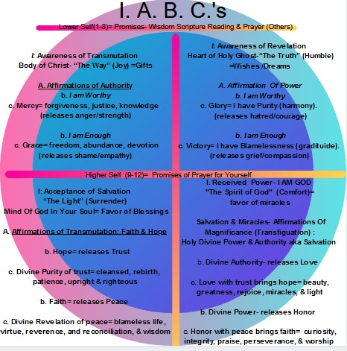
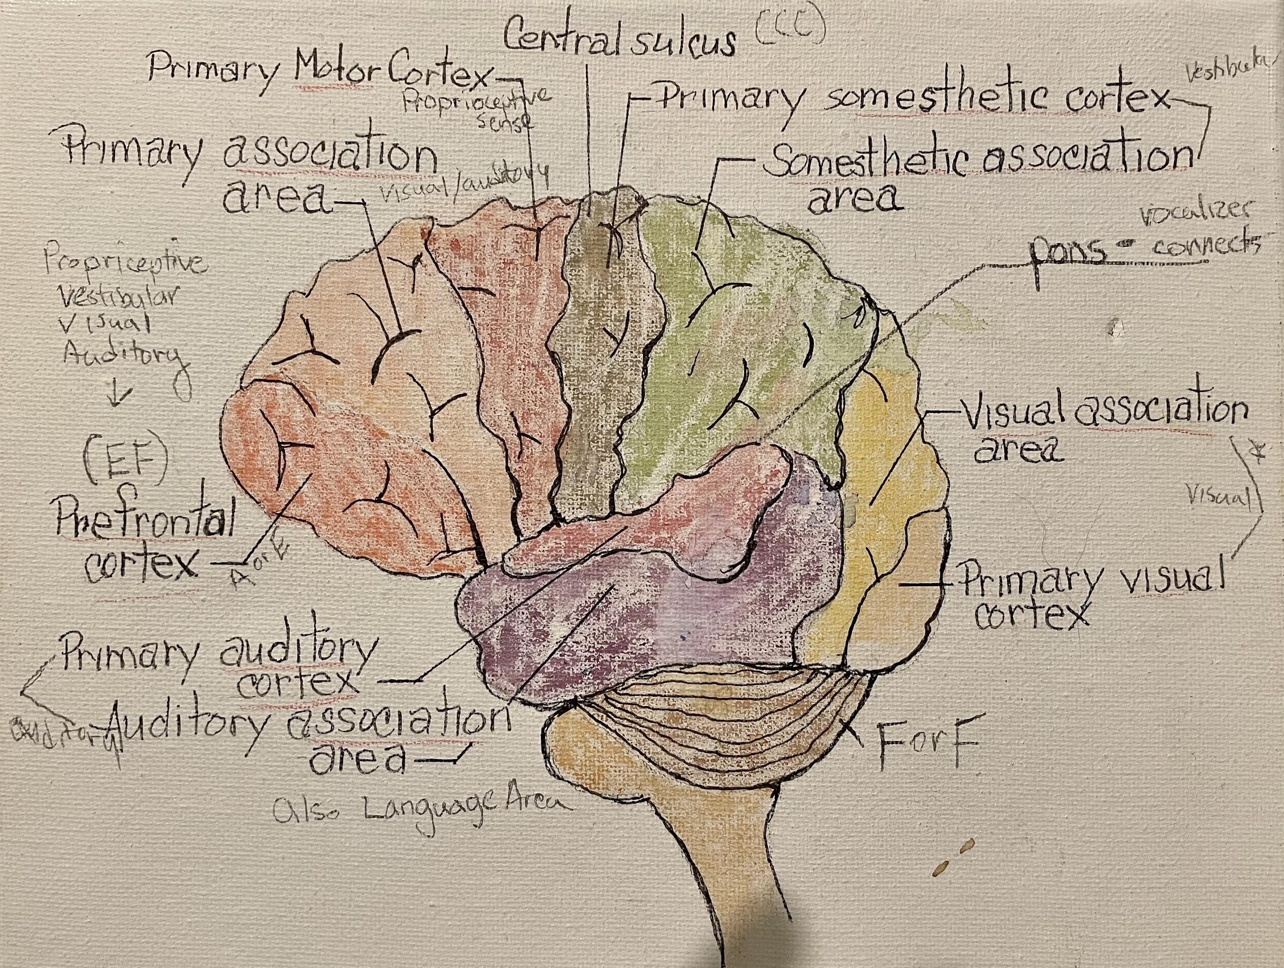
18 - NEEDING TO BE ADDRESSED- Our Dysregulation In OUR Biofield “Our Senses” (see chakras below)
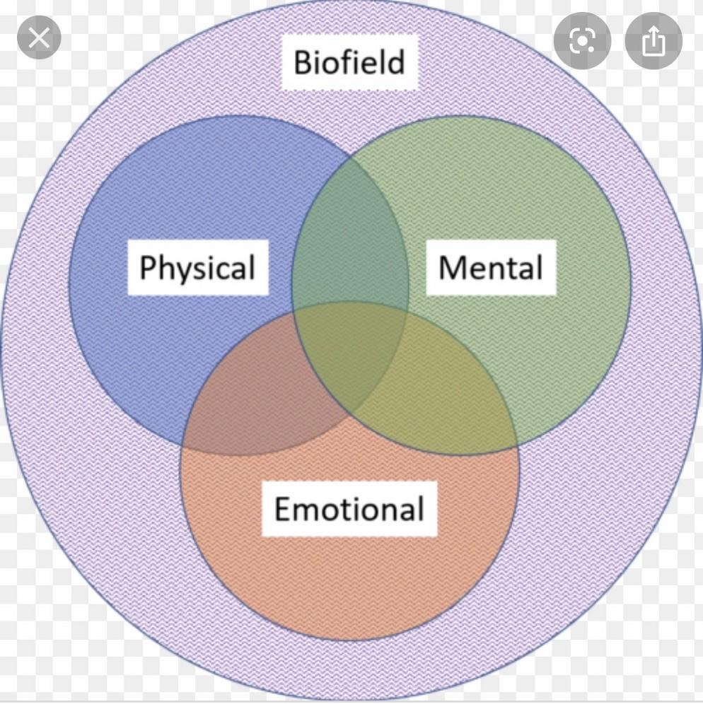
19 - 3.1 Biofield illustration

Our Chakra "Energy" System
Relationship Memories Appear From Cellular Memory (Thymus):
Learning Differences including Our Chakra Systems & The Vagal Tone
The chakras spin like a wheel which fuels our MIND (thymus) and EM and Torsion Field. The chakras spins like a wheel and sets our minds’ vagal tone (ultimately thymus) which can be Hypo- or Hyper-, Varied. The chakras need to be balanced and equalized for our mind (thymus) not to be dysregulating our senses nor other systems. When your child has a Hypo- or Hyper-, Varied Responsive System Dysfunction (RSD), their learning and motivation (attunement) through their senses decreases due to disconnections to others-themselves along with soul-body disconnection of consciousness. The hypo-Anger Sympathetic Functional Dominance (SFD) means certain chakras (usually 1st-8th chakras) are spinning too fast in which the lower self needs strength. The hypo-Shame Parasympathetic Functional Dominance (PFD) means they are spinning too low and need empathy. If varied Total Functional Dominance (TDF), the lower self (1st-8th chakras) are going deactivated or going inactive along with thymus and need both strength and empathy including joy, bliss, and peace. Note: the 8th chakra includes the vagus nerve (thymus), in turn includes alta major and soma chakras.

Body (Physical, Mental & Emotional)
--------------------Physical Ruled by 2nd chakra--------------------
(suggestion: consciousness begins around age 2 years)
-1st chakra (base) Shame/Empathy- meaning
-2nd chakra (sacral) Peace, Bliss and Joy (happiness)- motivation
-3rd chakra (solar plexus) Anger/Strength (can do 1 & 3 together- gaia gate)- meaning

-------------------Mental Ruled by 8th chakra (RAS)--------------------
(suggestion: starts to develop around age 7, big jump at age 12+)
-4th chakra (heart) Hatred/Courage- meaning
-5th chakra (throat) Grief/Compassion (can do 4 & 5 together-earth star)
+thymus (see number 8 below)- meaning

------------------Emotional (mind and cellular level) Ruled by 8th chakra (RAS)
-6th chakra (third eye) Grace (freedoms-abundance, devotion)- motivation
-7th chakra (cosmic) Mercy (forgiveness-release fear/unconditional love)- motivation
-8th chakra (crown) “high heart-mind=soul chakra”- Glory-gratitude/Victory-harmony (Includes the vagus nerve (thymus), in turn includes alta major and soma chakras (RAS, Pons)- ultimate motivation (soul level)

Soul- heart and mind
--------------------BODY-SOUL CONNECTION Ruled by 11th chakra (ARAS)--------------------
(suggestion: start to work after the age of 21+)
-9 chakra (star child) Divine Purity (Hope- cleansed, rebirth, patience, reverence, and righteous) - meaning/ motivation (spirit level)
-10th chakra (causal) Divine Revelation (Faith- blameless life, virtue, and reconciliation) - meaning/ motivation (spirit level)
-11th chakra (soul star) Divine Power (connection, curiosity, integrity, honor, and trust) & Divine Authority aka Salvation (beauty, greatness, blessings, miracles, and light) (can do 9, 10 & 11 together) - ultimate meaning/ motivation (spirit level)
--------------------Authentic SOUL-SPIRIT CONNECTION--------------------
(suggestion: super consciousness starts around age of 30+)
-12th chakra Divine Unity (stellar gate) gifts, wishes, blessings and miracles (peace and comfort) through Divine Love- Hope, Glory, & Mercy; Divine Honor- Faith, Victory, & Mercy

“The Lord bless you and keep you; Lord make his face shine on you and be gracious to you; Lord turn his face toward you and give you peace.” Numbers 6: 24-26
Affirmation of Faith: I am blessed. I have peace.

Spirit
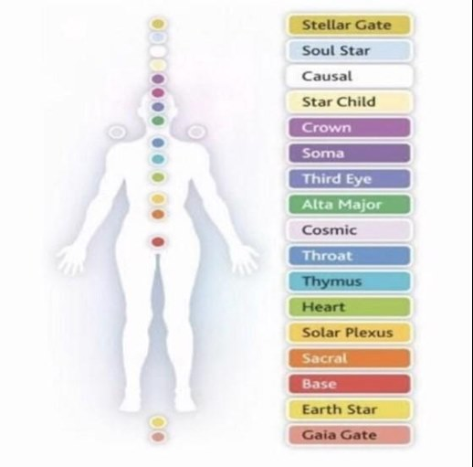
20 - 3.2 Chakra illustration (see below)- NOTE: 1st is Base (shame) and 3rd is Solar Plexus (anger); * for kids the 8th chakra Thymus, Soma, Crown, & Alta Major is key as well as 1st & 3rd.
Note: The Earth Star and Gaila Gate (bottom two) along with Stellar Gate (top) can’t be worked-on just have to be prepared to lighter as healing goes on along with receiving honor, wisdom, and glory. Glory has indescribable attributes.

“Open up, ancient gates! Open up, ancient doors, and let the King of glory enter.” Psalms‬ 24:9‬ NLT‬‬‬‬‬‬

Our Electromagnetic System “Our Senses”& The Brain
Our Electromagnetic System “Our Senses” affects other parts of the brain that have a part in some of the most important aspects of learning which includes the following tasks:
analysis (break down category and sequencing)
sensory processing
memory/learning (short and long term memory)
motor control
autonomy (meaning) and attunement (motivation)
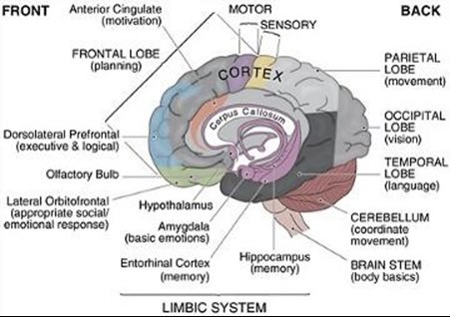
21 - 3.3 image Cook’s Brainchat 7/30/20 illustration
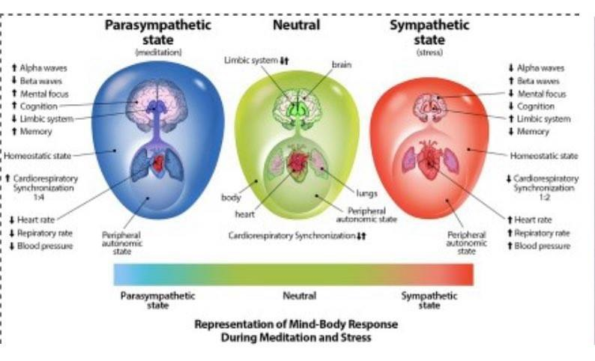
22 - Image 3.4 Note: Limbic system up for sympathetic state and down for parasympathetic, neutral in equalized
Sympathetic State (Mental Bodies)- anger, fight and flight, hyperactive thymus (upper-heart chakra) resulting in hyperactive systems and senses.

Parasympathetic State (Emotional Bodies)- shame, freeze, hypoactive thymus (upper-heart chakra) resulting in hyperactive systems and senses.

GOAL: A Neutral State, when learning under stress, of equanimity of the structures and interacting areas of the limbic system are involved in motivation, emotion, learning, and memory. The limbic system is where the subcortical structures meet the cerebral cortex. ... The limbic system also interacts with the basal ganglia.
NOT A Functional System Dominance (FSD)- when the RAS & ACC (anger)/HPA (shame) and the brain stem (reptilian brain) regulates our sympathetic (anger) and parasympathetic (shame) systems as it responds to stress: such as when reading. It also acts as a vehicle for sensory information. Note: Students with Sympathetic Functional System Dominance (anger-SFD) have mostly hyper-sensory processing and Parasympathetic Functional System Dominance (shame-PFD) has hypo-sensory processing and Total Functional System Dominance (both anger and shame- TFD) and varied processing. This disequilibrium of the systems can make appropriate learning behavior more or less challenging such as: self-regulation, attention and executive functioning, oppositional and aggressive behavior, anxiety and possibly even depression.

NOR A Responsive System Dysfunction (RSD)
Lastly, it helps to be familiar with the midbrain (mammalian brain) which includes: medulla oblongata and pons do their jobs effectively such as…
Basal ganglia- regulating motor functions. Students with Sympathetic Functional System Dominance (anger-SFD) have mostly hyper-sensory processing and hyperactivity in their proprioceptive, somatic, vestibular, and gross-motor abilities (ADHD- hyperactive type & cerebral palsy) and Parasympathetic Functional System Dominance (shame- PFD)- have mostly hypo-sensory processing and hypoactivity in their proprioceptive, somatic, vestibular, and fine-motor abilities (ADHD-inattentive type & dysgraphia). Varied is, of course, Total Functional System Dominance which is most common with dysgraphia (anger and shame- TFD).

Hippocampus- Parasympathetic Functional System Dominance (shame- PFD)- have mostly hypo-sensory processing and hypoactivity of the hippocampus which helps humans process and retrieve two kinds of memory, declarative memories, and spatial relationships. Declarative memories are those related to facts and events. Examples include learning how to memorize speeches or lines in a play. Spatial relationship memories involve pathways or routes. Spatial relationship memories appear to be stored in the right hippocampus. The hippocamp is also where short-term memories are turned into long-term memories. Relative to the hippocampus, these memories are then stored as polarities in the brain-experiences and reality of consciousness the past, future and present. (see RAS specially ACC above- associated with the alta major chakra and shame and see PONS and Thymus below)
JESUS (Mental Body) RAS the aka neocortex (Body & Brain- breath). It's the cognitive and physical "what" which is the "The Way".
to
Holy Ghost (Emotional Body) PONS aka limbic system (Body & Mind- breath). It's the affective and the physical "why" which is "The Truth"
to
God (Etherical Body) THYMUS aka reptilian (H. Heart & Mind- authentic breath). It's the God-Soul connection, authentic self connection which is infinte "The Light".

God is the "The Life" so NEEDS TO BE REVERSED- But, Still Three is Key To All Learning!!!
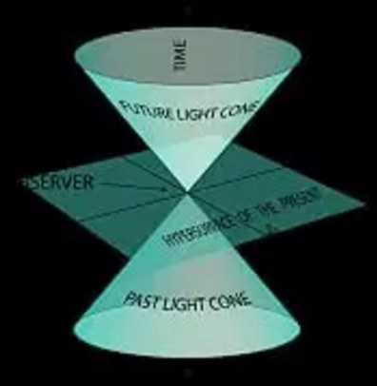
23 - 3.5 Light Cone (perceptions of past, present, & future)
*Aside: Interesting Research- on those with memory loss, they did have faster thinning of the entorhinal cortex due to amyloid level as well as brain shrinkage of the hippocampus [retreived on 4/25/20 Scienmag. “SCIENMAG.” What Comes First, Beta-Amyloid Plaques or Thinking and Memory Problems?, apple.news/A0bfYT-YLR2u8kRquMsjKRA?fbclid=IwAR2].
Relevantly, the Wnt pathway has been recognized as critical for the central nervous system development, several Wnt components retain their expression in the adult brain, including the hippocampus, and have proven to be fundamental in both the development and function of synapses (Inestrosa and Arenas, 2010; Inestrosa and Varela-Nallar, 2015). Altogether, these findings strongly suggest that Wnt signaling might be down-regulated during aging, leading to increased vulnerability of the neural network and increasing the risk for the onset and progression of age-related pathologies, such as AD. Wnt inhibitors, including the secreted-frizzled-related protein 1 and 2 (SFRP-1 and SFRP-2) and Dickkopf-1 (Dkk-1), all them antagonists at the cell surface. As a result, mice deficient in Dkk-1 exhibit enhanced spatial working memory and memory consolidation and also show improvements in affective behavior (Caricasole et al., 2003, 2004) [Retrieved from Scienmag. “SCIENMAG.” What Comes First, Beta-Amyloid Plaques or Thinking and Memory Problems?, apple.news/A0bfYT-YLR2u8kRquMsjKRA].
***Ask me about the dorsal raphe nucleus at the brainstem, TDP-43 (FTLD–TDP) folding proteins, beta-amyloid plaque build-up, Dkki-1 at the midbrain stem, prefrontal cortex and the frontal lobe for Alzheimer’s (dyslexia as well). Also ask me about the RAS-conscious around the age of three, ARAS and God awareness age 21–25 (Petty, Peter G. “Consciousness.” Journal of Clinical Neuroscience, vol. 3, no. 4, 1996, p. 390., doi:10.1016/s0967-5868(96)9004.

Pineal Body, Pituitary & Adrenal Glands (see hypothalamus below)- synthesizes melatonin, serotonin, and dopamine and cortisol which helps you respond to stress (reading for example) and has many other important functions. Also melatonin studies recently show that melatonin exhibits many bioactivities, such as antioxidant activity, anti-inflammatory characteristics, boosting immunity, anticancer activity, cardiovascular protection, anti-diabetic, anti-obese, neuroprotective and anti-aging activity. Note: Students with Sympathetic Functional System Dominance (SFD) are deficient in dopamine, melatonin, and have hyer-norepinephrine production (diligence- fight, flight, flee & hyperarousal). Students with Parasympathetic Functional System Dominance (PFD) are deficient in serotonin, melatonin, and have hypo-norepinephrine production (hypoarousal, memory retrieval, diligence/motivation-freeze). Note: The pineal gland helps with a meditative state if the head is covered- it’s great for Calm (I will write more about calm ahead! Varied is, of course, Total Functional System Dominance (TFSD) which is most varied in hormones and the hardest time being calm with mood swings along gaining equanimity also can be diagnosed congenital adrenal hyperplasia. [Retrieved from 4/27/20 Singleton, Omar, et al. “Change in Brainstem Gray Matter Concentration Following a Mindfulness-Based Intervention Is Correlated with Improvement in Psychological Well-Being.” Frontiers in Human Neuroscience, Frontiers Media S.A., 18 Feb. 2014, www.ncbi.nlm.nih.gov/pmc/articles/PMC3927233/.]

Remember: ACC- is part of RAS (Pineal Gland, Pituitary Gland-associated with the alta major chakra), HPA- is also part of the RAS (Hypothalamic–Pituitary–Adrenal Axis- associated with the soma chakra) Both are associated to the thymus chakra aka vagus nerve chakra.

Medulla Oblongata at the EM Field Including the Pons
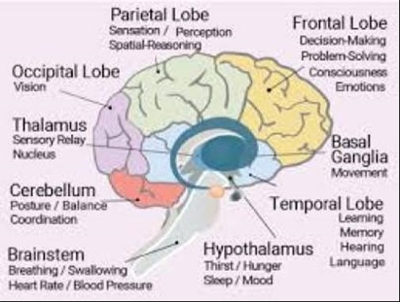
24 - 3.6 Internal Medulla Oblongata Brain illustration
Thalamus- integrates and sends sensory information such as autonomic functions (para/sympathetic) aka sensory relay nucleus.
Olivary body- motor learning and perception of sound (auditory and visual processing specifically).
Hypothalamus- speed processing of information also you need to remember the important RAS info. which includes the following excerpt: ‘The RAS is said to be the gas pedal [slow, accelerate or varied cognitive speed processing] that ignites the diencephalon (the hypothalamus and thalamus) as well as, the cortical areas [where all long-term memory/storage takes place] of the brain’ (Petty 1996). The lateral hypothalamus mediates an array of cognitive and physical processes that widely projects throughout the nervous system. Also, includes the hippocampus (see above)- which is in the limbic system and regulates perceptions (such as the perception of shame, long-term memory). Students with Sympathetic Functional System Dominance (SFD) react with anger and have hyper-speed (accelerated) processing and long-term memory issues (both also varied from trying to regulate accelerated-slow so one and so forth). Students with Parasympathetic Functional System Dominance (PFD) filters with perceptions of shame, have slow speed processing (also the controversial- slow cognitive speed tempo) and bypassing the facts needed for short-term memory (effects sequencing skills, background knowledge)-headed straight to filtering based on meaning and perceptions (again shame)- short term memory issues are actually a prefrontal lobe executive functioning issues. Again, the frontal lobe to perceive the universal emotions which are the following: anger, strength, joy, bliss, shame, courage, compassion, and harmony (executive functioning logic through analysis or evaluation) where the mind deems how important (what or why). Basically, Remember the PONS< RAS-alta major chakra, pineal and pituitary gland (pituitary chakra), crown chakra specifically for Parasympathetic Functional System Dominance (PFD) & PONS< HPA- soma chakra, hypothalamic–pituitary–adrenal axis for Sympathetic Functional System Dominance (SFD). Varied speed processing (hypo-, hyper-) is, of course, Total Functional System Dominance which is most common with dysgraphia (anger and shame- TFD) [Petty, Peter G. “Consciousness.” Journal of Clinical Neuroscience, vol. 3, no. 4, 1996, p. 390., doi:10.1016/s0967-5868(96)9004].

Note: "Brain and viscera interplay within the autonomic nervous system where the vagus nerve (VN), containing approximately 80% afferent and 20% efferent fibres, plays multiple key roles in the homeostatic regulations of visceral functions"- Please View Some VERY IMPORTANT Studies from Bruno Bonaz in France:

Bonaz, Bruno et al. “Anti-inflammatory properties of the vagus nerve: potential therapeutic implications of vagus nerve stimulation.” The Journal of physiology vol. 594,20 (2016): 5781-5790. doi:10.1113/JP271539

Bonaz, Bruno, et al. “The Vagus Nerve in the Neuro-Immune Axis: Implications in the Pathology of the Gastrointestinal Tract.” Frontiers in Immunology, vol. 8, 2017, doi:10.3389/fimmu.2017.01452

Chapter 4 The Spirit

The Divine Stamp- Soul & Body
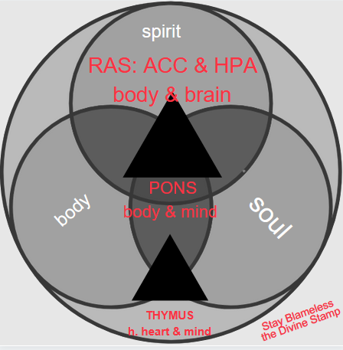
In a deeper sense, the divine stamp is our will to make a transformation, revelation along with renewal of strength and empathy by accepting Him, so we can heal ultimately in courage, compassion, harmony and unconditional love for others, and mainly ourselves in acceptance of the true mercy and grace of God! Discovering how to live a blameless and pure life once realizing the issues of learning and relationships HAD TO HAPPEN and ALL problems with others such as: being the teachers, school and learning, relatives such as brothers/sisters, or the other kids. It really isn’t others or the neurodifference itself; It is our understanding of the greater purpose in life (as many other's stories), so for the greater good to glorify His Kingdom! It’s our life’s lesson to the journey of learning to glorify God along with gaining his blessings of Peace, Freedom, and Victory.

Key Contemplation: Stay Blameless & Pure Know It ALL Had to Happen
Intention: God Awareness and Unity
Affirmation: I AM THAT...I AM SAVED- I AM COVERED IN THESE INTENTIONS IN MY BODY and SOUL WHICH INCLUDE THOUGHTS, IDEAS, MESSAGES, VIRTUES, FEELINGS, DREAMS AND VISIONS (see image 4.0 below)

Daily Functional System Regulation (DFSR) Thymus (Soul) -Pons (MidBrain)-RAS (Brainstem) VERSUS
Responsive System Dysfunction (RSD): *Dysregulation Functional System Regulation RAS (Brainstem)-PONS (MindBrain) DISCONNECTION THYMUS (SOUL)

*NOTE: Dysregulated and Dysfunctional System Responsive System Dysfunction (RSD) and Total Learning System Dysfunction (TLSD) works in a downward effect from RAS-PONS-THYMUS:

Daily Functional System Regulation (DFSR) THIS NEEDS TO BE REVERSED
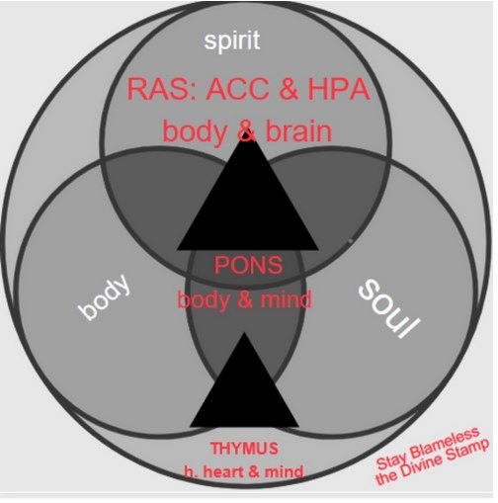
ALL our systems and senses need to function equalized, activated, and balanced for learning to take place. The triune brain which is the neomammalian complex (RAS- aka neocortex), midbrain (pons- aka limbic system), and forebrain (thymus aka reptilian) is working on a downward function. People are using their mental and emotional bodies to learn not their etherical body (etheric).

NOW ALL LEARNING IS IN THIS DIRECTION:

JESUS (Mental Body- 1st-3rd chakras) RAS the aka neocortex (Body & Brain- breath). It's the cognitive and physical "what" which is the "The Way".
to
Holy Ghost (Emotional Body- 4th-6th chakras) PONS aka limbic system (Body & Mind- breath). It's the affective and the physical "why" which is "The Truth"
to
God (Etherical Body- 7th-12th ) THYMUS aka reptilian (H. Heart & Mind- authentic breath). It's the God-Soul, authentic self connection which is infinte "The Light".

INSTEAD OF HOW THE SYSTEMS & FUNCTIONS WORK NOW
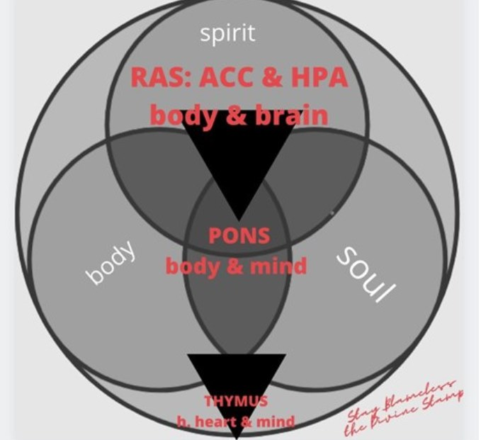
The Solution: When using the etherical body, ALL our systems and senses will function equalized, activated, and balanced. The triune brain which is the forebrain (thymus aka reptilian), (pons- aka limbic system), and the neomammalian complex (RAS- aka neocortex) needs to be working in an upward function. With a functional system, the child [or adult] can trust themselves and their gifts and learning uniquenesses through spiritual mindset with self-directed neuroplasticity through ABC’s and gain God awareness (eventually unity) through PYAM Daily.

God (Etherical Body) THYMUS aka reptilian (H. Heart & Mind- authentic breath)

to

Holy Ghost (Emotional Body) PONS aka limbic system (Body & Mind- breath)

to

JESUS (Mental Body) RAS the aka neocortex (Body & Brain- breath)
SOLUTION ABC’s & PYAM DAILY:
PART II & III CHILDREN- AGE 21: HERE & HERE

PART IV ADULTS: HERE

PART V ADULTS: HERE

The BRAIN BALANCING WITH THE BIBLE: HERE

Affirmation of Faith
The internal flame is the divine stamp of infinite and complete wholeness with God. There's peace and comfort knowing He is my help, lamp, and savior!! The way to a complete functional system again is replacing anger with strength and shame with empathy (adults hatred with courage and grief with compassion). Why anger with strength? Have you seen a paranoid, anxious, angry person, who's absorbed in their “ego”, ever want to face and examine their anger feelings and triggers? It takes a lot of strength to do this! Why shame with empathy? Have you ever seen a withdrawn, self-absorbed, and ashamed person who’s almost defeated, ever want to have empathy for themselves (or others)? Jesus has already taken their suffering, so stay blameless. Those with a SFD, or PFD or TFD just need to accept Him into their heart, actually thymus (internal-sacred flame- high heart, thymus) and ask for help by growing in eternal strength and wisdom to increase their own peace and comfort (harmony) while gaining infinite “wholeness”. This is the divine stamp that we are promised!
The Lord bless you and give you peace. Numbers 6:23-24
Affirmation of Faith: I am blessed. I have internal peace.

Acceptance of God’s Revelation

Anger: “Don’t sin by letting anger control you. Think about it overnight and remain silent.” Psalms‬ 4:4‬ NLT‬‬

Affirmation of Transmutation: I am calm. I have God’s faith.
Believe & Search your high heart (thymus) for Faith: I am worthy. Then, Peace will be realeased and you'll be blessed with blamelessness, virtue, and reconciliation.

Shame: “Answer me when I call to you, O God who declares me innocent. Free me from my troubles. Have mercy on me and hear my prayer.” Psalms‬ 4:1‬ NLT‬‬

Affirmation of Transmutation: I am righteous. I have God’s mercy.
Believe & Search your high heart (thymus) for Hope: I am enough. Then, Harmony will be realeased and you'll be blessed with cleaning, rebirth, patience, reverence and righteousness.
Blameless Lives

And this is my prayer: that your love may abound more and more in knowledge and depth of insight, so that you may be able to discern what is best and may be pure and blameless for the day of Christ, filled with the fruit of righteousness that comes through Jesus Christ—to the glory and praise of God. (Phillipans 1:9-11)
Key to developing a pure God-like perception is freedom. What is Freedom? It’s by becoming pure light and leading a blameless life! What’s a blameless life? What is a pure life? It’s having a God-soul centered life. Being God-soul centered, it allows us to be connected to God’s powerful and glorious light and allows us to communicate with God in questions and unveil his Sod! How? It’s to understand, apply His teaching and remember Him. How? I pray, read the bible daily, breath (praymana), do yoga and other brain-balancing exercises, meditate to unveil His sod (secret) by accessing the universal mind which is in the crown chakra, deep inside the pons area of the brain.
The Truth
What is Sod? No, I didn’t mean to write, The Truth of God (just yet). Sod is God’s secret- He’s kept a veil over His secret that was unveiled when Jesus died. It is the Sovereign Secret of the universe and everything that is within God’s Realm. What is the veil of God? I think His Sod includes the veil of God; the veil is how we change how we communicate to God to find out the secrets. Meaning, His sovereign secret is that you can unveil His Sod- held with-in the thymus when you meet-your-akashic-guide to become part of the ‘universal mind’ through questions. After all, the questions and answers are both in your universal mind for your knowing! This is why He made our ability to have speech along with higher-order thinking; hence, the frontal cerebral cortex and pond area of the brain was given to humans.
By asking God “what’s my question?” Therefore; I have had to let God give me the questions such as: have you ever asked yourself the question, should hold on or hold out in your relationship? Why do we have to hold on or hold out? It’s the giving and taking that occurs in most relationships; I’m not talking about the giving and taking of material, earthly possessions. Let’s think about God- does he take from us ever? No, He just requires us to love him in the purest, most authentic form and fashion. Why do we have to give and take? Especially, why would we ever need to give someone our hearts, then take it back when things go down. Why do we have to give and take or hold on or hold out? Doesn’t this just lead you to hurting. Jesus didn’t die to have us lead a life hurting with-in ourselves and others. He wanted to live a life of surrender, acceptance--mostly unconditional love!
How can you give something to someone if you don’t have it for yourself? I didn’t have a true, purest love for myself, so how could I ever give it to someone else? The thing is, if you have freedom in your life, you can not worry about these questions. Freedom is abandoning any thoughts of fear and lack of self-worth and returning to authentic love. This is the truth of God; It’s giving to yourself what God has given us which is freedom. How do you gain freedom? It’s a process and not automatic; for a second, also don’t think it doesn’t require a lot of prayer for deepest most heartfelt strength and empathy that comes from with-in your core spirit! It can be deep because through life experiences it can somehow be lost or forgotten or even overshadowed by hatred (lack of love).
First, it requires courage and mercy- the courage to deal with your own pint up anger that you never expressed because ‘you are a Christian, and you don’t get angry’ and have mercy on yourself for ANY shame you have been holding inside your body. Again, the shame and anger can go deep depending on your circumstances. But thanks to Adam and Even, anger and shame is what is naturally and innate inside all of us. The shame and mercy innermost “work” can lead us to the best freedom and that would be experiencing God’s grace. Second, you have to have knowledge and wisdom. The knowledge comes from studying the Bible and thinking and applying what you read. This takes obedience and self-discipline which is “work” because our lives are full of distractions from God (if we let them). Wisdom is the willingness to listen to that inner voice, paying attention to signs and symbols along with being open to hear from angels and most importantly God. Then, you can start to perceive life as God perceives us. The knowledge and wisdom “work” that you do can lead you to surrender completely to God. The first two steps in this process to freedom can already be transformational in clearing, transmuting the negative circumstances that were in your past which was keeping you from truly loving yourself. They can also have the added power to increase your strength and empathy that you need to get through the rest of the process to freedom.
‘Present your requests to God, which transcends all our understanding’ Philippians 4:4-9
Spirit includes the high heart and soul
Divine Authority
The pons area and the frontal lobe have several important and pertinent purposes in our lives: The pons controls our breath known as ‘life’ of God. God gave us the ‘life’, so we can be the breath of God along with leading a pure and blameless life. The pons just doesn’t serve to help the different lobes communicate which balances the brain but also is the veil of God. The brain-balancing of the Yin/Yang which are the male and female sources of energy in our lives is very important. The pons area also contains the trapezoid body where you are able to vocalize sounds. This allows us to sing and share His word, ultimately leading others to God. I think the pons area also includes the ‘universal’ mind with God that we all share. How do you think He knows our thoughts, feelings, sins (meaning back to thoughts/feelings), etc? Yes, we share a common mind with Him, His Kingdom (Realm) which is all stored and kept secret-literally needs to be unveiled. Also, the ‘universal mind’ includes everything seen and unseen, past, present, future, infinite, finite: Lastly, us and everything in existence and even non-existent (exist at one time, at that time, aka the here and now)!
Divine Power
This is the power of God; It’s KNOWING EVERYTHING is contained in His Plan leading us to a blameless and pure life here on earth. Note: It's everything that can be unveiled but has been restricted from our frontal lobe within time and space perception restrictions, while the pons area of the brain connects and vocalizes such as the word "Alleluia" or "Hallelujah" (from Hebrew הללויה) which literally means "Praise the Lord". The form "Alleluia" is also used to refer to a liturgical chant in which that word is combined with verses of scripture, usually from the Psalms. After all, the questions and answers are both in your universal mind for your knowing! Afterall, this is why He made our ability to have speech along with higher-order thinking/questioning; hence, the frontal cerebral cortex and pons area of the brain was given to humans. He also needs us to apply what He communicated in the Bible, recreate for change, and, most importantly, remember Him. Again, the frontal lobe is what God does for us! He also needs us to apply what He communicated in the Bible, recreate for change, and, most importantly, remember Him.
For the Lord God is a sun and shield; the Lord bestows favor and honor; no good thing does he withhold from those whose walk is blameless. (Psalm 84:11).
Chapter 2 BALANCE Body (heart, brain) With Scripture & Prayer
Having problems with learning and others? The trinity is there to help. First, Go to the Spirit (middle column below), then the soul (body right- below), then the heart (body left-below).
Purpose of The Trinity:
Birth- Puberty: Surprise & Mystery
Adulthood-Elder: Support & Comfort
I. A. B. C.'Scripture Reading and Prayer That Supports Lower & Higher Self:
The mind & soul God (9-12) Show (sight) & Tells You (hear) IN WORD ABOUT The Future So Pray
The heart Holy Ghost (4-8) Counsels & Advocates You Presently
The body & breath Jesus (1-3) Heals The Past
*The Trinity- THREE IN ONE
Body Left
Jesus
Thymus (High Heart- Mind)
God
Body Right
Holy Ghost
“The Messiah” “Savior”
Purpose Assistance (Midbrain- RAS HPA/ACC)
Masculine which is the Sun (new brain)
Jesus (twin flame) Severity-Wisdom (Body & Brain-RAS HPA/ACC) (1st heaven- still waters and the Mount) and the Past already paid and given.
Awareness-actions and
Assistance (Jesus)
Sacred Flame-United, Will-Love of God-Soul:
Mercy- Knowledge
Grace- Wisdom
“God (Nina)”
Purpose Guidance
(aka. Shadow-Flaming Sword “His Word” and prayer)
A Holistic Balance of Virtues through Challenge, Power & Love, It’s the Mind- Thymus (3rd heaven- high heaven) and Future coming to God blameless and pure!
Received- the Truth Guidance (God):
Wrath-Peacefulness
Lust-Purity
Pride-Humbless
Greed-Submissiveness
Sloth-Grace
Gluttony-Impartialness
“The Advocate” “Counselor”
Purpose Empowerment (Heart, Soul)
Femine (old brain)
Holy Spirit (Numa) including Archangels/Archeia (twin flame). It’s the Pons (Body & Mind) (2nd heaven- angels lie) and the Present- The resurrection of the body will come soon.
Accepted-beliefs and
Empowerment (Holy Ghost):
Sacred Flame-United, Will-Love of God-Soul:
Glory- Freedom
Victory- Wisdom
(Blue)
Power
Hope
Glory
All Through Gods, Mercy
Leads to Eternal Harmony
(Yellow-gold)
Unconditional, Unexplainable,
& Infinite
(Pink)
Love
Faithfulness
Victory
All Through Gods, Grace
Leads to Eternal Peace
Ascended Master Saint Germain and his divine complement, the Ascended Lady Master Portia
The Foundation of the 3 Pillars- Gaia- (Mary- Jesus’ Mother) Mother Earth who is mother to the four elements, archangels, and archeia along with who they represent. She keeps the pillars balanced and helps connect us to the Holy Trinity.

For the Lord God is a sun and shield; the Lord bestows favor and honor; no good thing does he withhold from those whose walk is blameless. (Psalm 84:11).

Neuropedagogy & IQ- Disparagment of Perceptions
What is neruopedagogy? Neuropedagogy as a scientific discipline: interdisciplinary description of the theoretical basis for the development of an educational research field of the mind, brain and body; Basically, it is when science and education meet, and whose scientific aims are to learn how to stimulate new zones of the brain and create connections. It also merges neuroscience, education and psycology including (w)holism. 'It is targeted at stimulating the brains of all types of learners, not only those with students who have learning differences. Applying the findings from neuroscience to teaching and learning.' [Retrieved from Sara Naegele, MSEd and Dechantal Montano. “The Fundamentals of Neuropedagogy.” Brain Blogger The Fundamentals of Neuropedagogy Comments, brainblogger.com/2015/01/25/the-fundamentals-of-neuropedagogy/.]
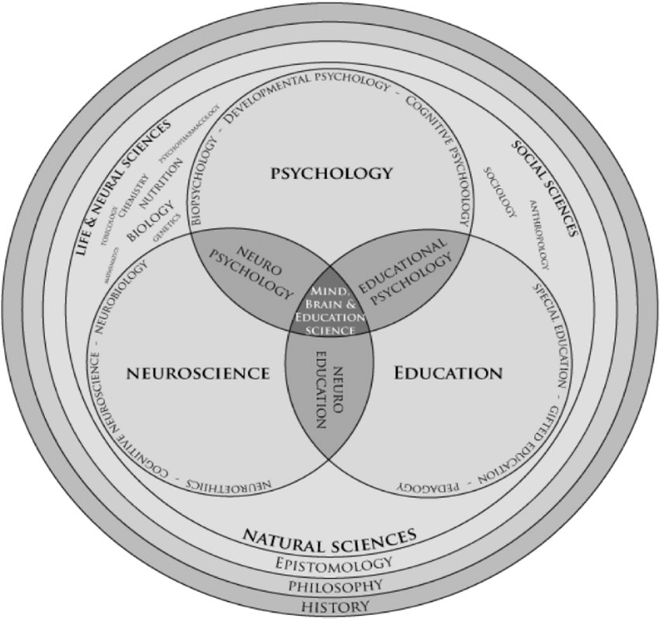
25 - https://www.researchgate.net/figure/Diagram-of-new-interdisciplinary-research-areas-19_fig1_331231903
"The core is not developing the new chakra-system, but rather to expand your consciousness beyond what is perceived by the monkey mind.” [Retrieved from Ourangelsguidance. “THE 12 CHAKRA SYSTEM AND TWINFLAME PROCESS.” Our Angels Guidance, 13 Nov. 2016, ourangelsguidanceblog.wordpress.com/2016/11/13/the-12-chakra-system-and-twinflame-process/.]
The average score on an IQ test is 100. These labels are often given for IQ scores:
- 1 to 24: Profound mental disability
- 25 to 39: Severe mental disability
- 40 to 54: Moderate mental disability
- 55 to 69: Mild mental disability
- 70 to 84: Borderline mental disability
- 85 to 114: Average intelligence
- 115 to 129: Above average or bright
- 130 to 144: Moderately gifted
- 145 to 159: Highly gifted
- 160 to 179: Exceptionally gifted
- 180 and up: Profoundly gifted
[Retrieved from Cherry, Kendra. “Do You Have a Genius IQ Score?” Verywell Mind, 3 Aug. 2020, www.verywellmind.com/what-is-a-genius-iq-score-2795585.]
If you are questioning if the thymus houses the mind, then ask yourself have you ever felt or thought something outside your own consciousness (maybe you found something out as you were journaling)? Try asking yourself is this true? You might even perceive something in a different way? Read below because what I’m asking and presenting to you might change your perception.
This cubed model of intelligence (see below) should be added to the ‘triarchic theory’, “this theory of intelligence has three aspects: analytical, creative, and practical (Sternberg 1985). Analytical intelligence, also referred to as componential intelligence, refers to intelligence that is applied to analyze or evaluate problems and arrive at solutions’. [Retrieved from https://www.simplypsychology.org/intelligence.html].” ‘This is a major theoretical issue for psychologists because they are divided on which perception [the mind] relies directly on for information in the environment. Some argue that perceptual processes are not direct, but depend on the perceiver's expectations and previous knowledge as well as the information available in the stimulus itself.’ [Retrieved from https://www.simplypsychology.org/perception-theories.html].
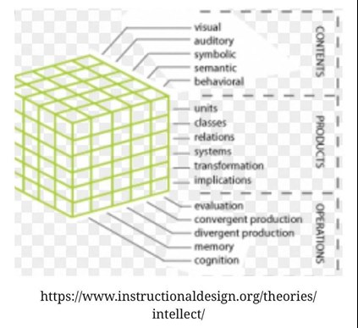
26 - image 4.3 cubed model of intelligence illustration
I want you to think about the Necker cube, which is sometimes used to test computer models of the human visual system, to see if consistent interpretations of the image are the same. There is evidence that by focusing on different parts of the figure, one can force a more stable perception of the cube.

As listed above on the cubed intelligence model, I need you to note under operations with convergent and divergent operations. Most people are convergent and have deductive reasoning and convergent thought. Those with neurodiversity have divergent production and have inductive reasoning and divergent thought. This is not the norm. The convergent production is based solely off of the “scientific method”- this thought process involves answering “what” with facts/form and function with theory, hypothesis, testing, and conclusion. The divergent production wants to answer the “why” using with feeling/future with their own observations, patterns, hypothesis and theory. In time, they observe what’s developing in their own perceptions of their mind through symbolic, behavioral contents, then evaluative memory of certain relations, systems, transformation and implications before they come up with a variety of never been used ways for a solution. [Retrieved from “Best Child, Career Counselling and Assessment Center in India.” Energiasoi, www.energiasoi.com/.]
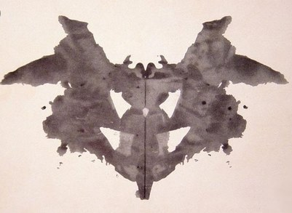
Lastly, think about the Rorschach Test, which is a projective psychological test, by Hermann Rorschach developed in 1921. Approximately, how many neurodiveregent learners are in existence? 23% of all learners, just under 1/4 of children and adults. The neurodiverse percieve words and their symbols as we do the images known as inkblots. The emotions give us our subjective view of what we read, write, speak and hear. This is why testing should be obsolete; this can not be tested. In my perspective all IQ testing nor standardized tests (even those by gold standard) are not set up for neurodivergent learners; Actually, most of education isn’t revolutionary and set up to tests this divergent way of thought- along with the authenticity of each person’s mind. Anything that is subjective or factual knowledge and not wise doesn’t meet the needs nor natural inquiry of the divergent minds’ perspective. -Tricia Cook Tcooktutoring.

Here are a couple of reasons why read as follows:

I argue, the IQ is a fluid as a person's EQ depending on the mindset, situational triggers, circumstance, and environment as well as what is mentioned prior when writing about functional systems and senses. This is why when they get the results from neurophycologist, the parents say to me, 'this isn't right I KNOW my child is intelligent'. I usuallt agree and say I know at home and with me they are...not in a place they've nevern been into before with people they just met nor with such pressure to do well on testing!!

I also argue that he cubed model (image 4.3) should be added to how we test IQ because it takes the variance of human perceptions held inside the thymus which is our "central intelligence", which again is part of one's spiritual mindset and takes into account: variences in experiences such as contents (facts), products (form/ functions), and operations (feelings/future) (see my Lesson Plan in Part II of Nurture Their Nature).

● ● ● GOD● ● ●Further Focus
Before we move onto the next section on how to help yourself and your child. Please ask yourself this question not from your brain, heart but from your mind these questions:

PONS Abstract Thought (spiritual conscious begins develops around age 7, makes a jump at 12)
Self-regulation:
Is s/he frequently irritable?
Does s/he overreact to small problems?
Does s/he have intense, angry outbursts?
Does s/he have outbursts for little or no apparent reason? (specify situations in which outbursts occur)?
Attention and Executive Function:
Is s/he easily distractible; does he act without thinking?
Is s/he restless, not able to sit still; is he overly active?
Does s/he have difficulty initiating or finishing tasks such as homework?
Does s/he have difficulty finding things in his/her room or desk?
Is his/her written work poorly organized, does s/he have difficulty planning ahead?
Does s/he forget to hand in homework?

PONS Abstract Thought (spiritual conscious begins develops around age 7, makes a jump at 12)
Oppositional and Aggressive behavior:
Is your child destructive to toys or other objects?
Does s/he say “no” or refuse to comply when asked to do something?
Does your child regularly argue with you (parents), teachers?
Does s/he tease or bully another child? Has s/he been teased or bullied?
Is s/he aggressive with siblings, peers or adults, e.g., hits or pushes?
Does s/he swear, call names or make threats?
Anxiety:
Do you think your child worries more than other children?
What does s/he worry about?
Does s/he ever have problems falling asleep because she is worrying about something, can’t turn his/her mind off?
Does your child have many fears?
Is s/he easily scared?
Can s/he be easily comforted by reassurance?

THYMUS SuperConscious Thought Cont. (around age 21–24, makes a jump at 30)
Depression:
What is your child’s mood like most of the time?
Is s/he often unhappy, sad or tearful?
Does your child’s mood change abruptly for no apparent reason?
Have you noticed a change in his/her interest in things s/he used to enjoy?
Have you noticed a change in his/her energy or activity level?
Is s/he more quiet than usual?
Have you noticed a change in his/her sleep patterns or appetite?
Questions By The Research Autism Group or online [Accessed 16 Dec. 2019].

View Works Cited Here and Please Share Nurture Their Nature (using This Link): https://sway.office.com/1oVk0WumcYeOtVON?ref=Link

Part II READY NOW Nurture Their Nature: BY HEALING OUR VERY OWN [LEARNING] DIFFERENCE
Beloved, let us love one another: for love is of God; and every one that loveth is born of God, and knoweth God. 1 John 4:7 (KJV) There is no fear in love; but perfect love casteth out fear: because fear hath torment. He that feareth is not made perfect in love. 1 John 4:18 (KJV)
Affirmation of God: I am love. I have harmony.
Disclaimer: These checklists and questionnaires are not to be substituted for professional Medical advice. These are the opinions of Tricia Cook and should not be used to diagnose or prescribe. Tricia is not a doctor.
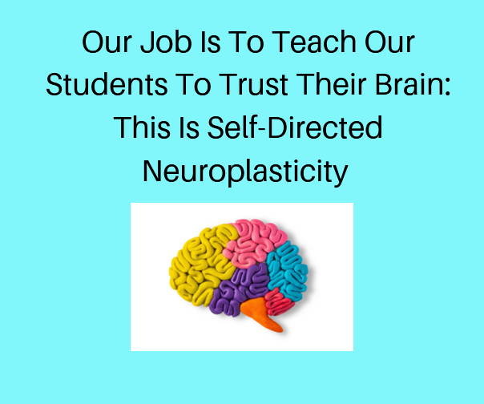
27 - www.myelbert.com

“To Preview the Book Nurture Their Very Own Nature By Looking To Heal Our Very Own [Learning] Difference: Press Here” — @help_dyslexia https://link.medium.com/t3PgLlQqBdb or Purchase Here
PLEASE NOTE:
Start above- Ask me to consult with you or someone else reach me via email: tcookmyelbert@gmail.com.`
Disclaimers & Such
- This Site Contains Affiliate Links, Pictures Are Either
Creative Common Licensed From Either WordPress or Canva

This communication may contain privileged and/or confidential information. It is intended solely for the use of the addressee and viewer recipient. If you are not the intended recipient, you are strictly prohibited from disclosing, copying, distributing or using any of this information. If you received this communication in error, please contact the sender immediately and destroy the material in its entirety, whether electronic or hard copy. This evaluation, program, and suggestions are not to be substituted for professional medical advice. They should not be used to diagnose or prescribe. Tricia is not a doctor but the information could change your life!
© ELBERT™: EVERYONE LEARNS BETTER EMBRACING REVOLUTIONARY TEACHING!!! 2021 My Elbert: The Gift Of Dyslexia Built with Storefront & WordPress.com.

Please Share
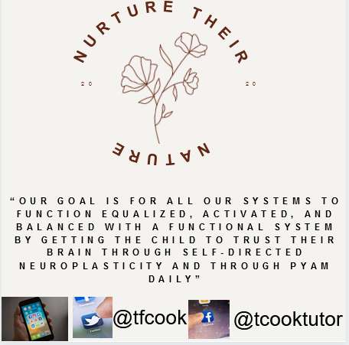
ELBERT™: EVERYONE LEARNS BETTER EMBRACING REVOLUTIONARY TEACHING!!! Helping Those with a Neurodifference Enjoy Learning Again

Beloved, let us love one another: for love is of God; and every one that loveth is born of God, and knoweth God. 1 John 4:7 (KJV) There is no fear in love; but perfect love casteth out fear: because fear hath torment. He that feareth is not made perfect in love. 1 John 4:18 (KJV)

“ELBERT develops connection, trust, and love by instilling curiosity, autonomy, and attunement in our students.”
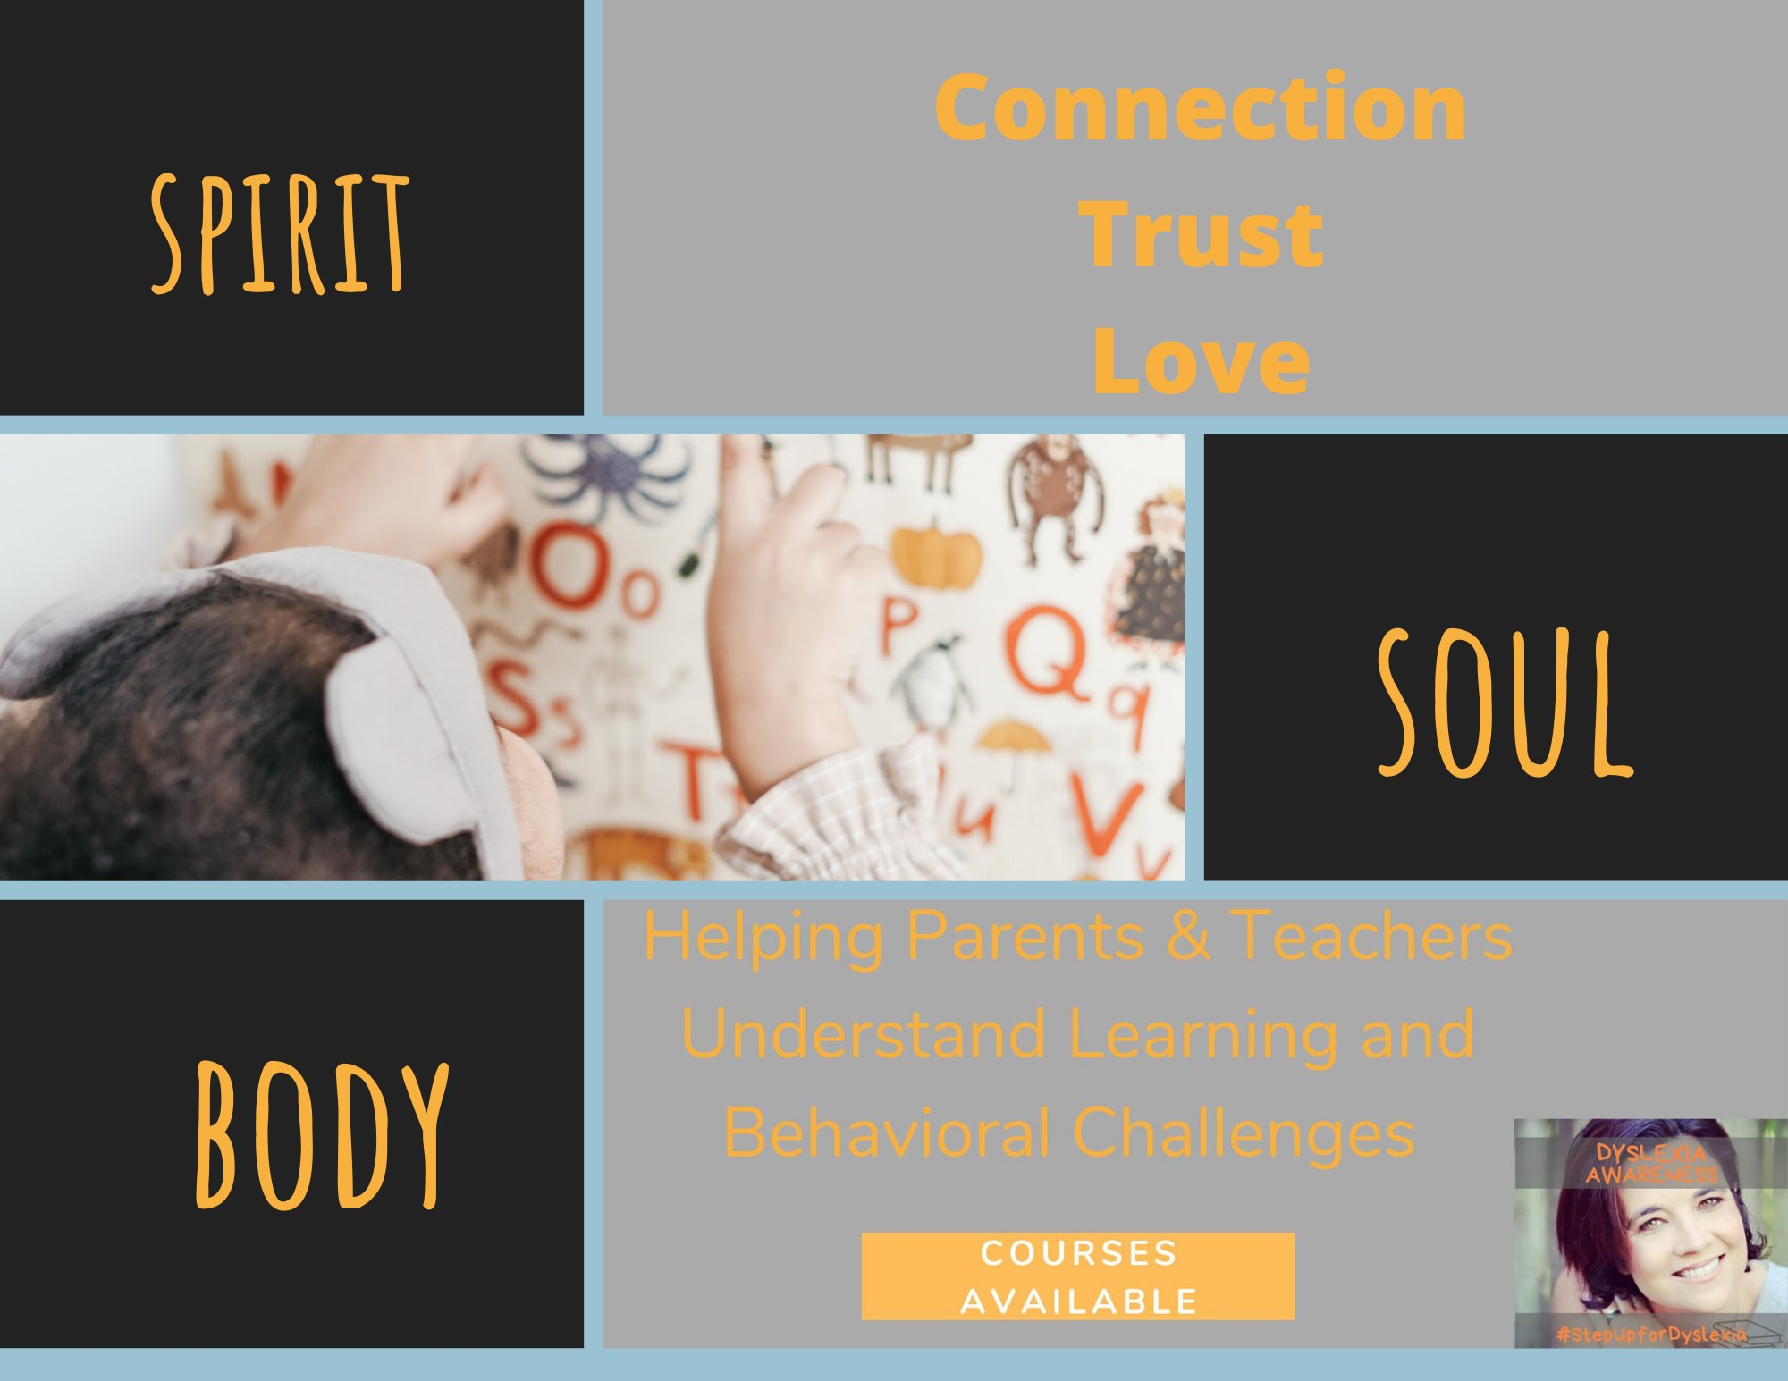
28 - Nurture Their Nature: Above is a Preview & HOW TO PURCHASE MY BOOK WHICH includes over 200 exercises and activities TO Help THE Universal EMOTIONS OF A LEARNING DIFFERENCE
Preface
Speaking of the “whole child”- you need to examine every aspect of “the whole child” not just the end goal or result which is literacy and their appropriate learning behavior.
The program I developed is named ELBERT™ which results include less passive student engagement, confidence, health and wellness including more pleasurable learning while participating in learning activities. Speaking of the “whole child”- you need to examine every aspect of “the whole child” not just the end goal or result which is literacy and their appropriate learning behavior. This program looks at the “whole child” and their unique neural development, complete learning differences including the nature and nurture of the neurodifference including their chakras, biofield (EM Field), and nervous systems.
I’m now making my expertise available to parents, teachers, administrators, stakeholders and other learning communities. I observe the student’s sensory acute response to stress and interview teachers, the child, and parents, observe input/output of motor, verbal, and written behaviors in response to a literacy activity such as a phonics inventory, word- sound knowledge, phonological awareness exercises, and working memory activities along with the student’s interest survey and overall behaviors based on executive, somatic and autonomic functioning. My program is named ELBERT™ based on the triune brain which includes the following: Brainstem- I have a fight, flight and freeze sympathetic/parasympathetic observational checklist; Midbrain- a screening for vestibular, proprioceptive, somatic issues, along with speech/language development, auditory and visual processing; Limbic- My lesson plan template that includes the 4 F’s: Facts, Forms/Functions, Feelings & Future along with a progress monitoring tool; Cordial- holistic, alternative suggestions for taking care of the whole child’s individual, dynamic needs which includes over 200 exercises and activities.
Do you offer trainings for parents, teachers, tutors or other RSP? As you know, schools, organization, and families are desperately looking for an effective, alternative type of affordable multi-sensory, handshakes-on, and interesting instruction for learning differences. With my new program ELBERT™, I am searching to tell my story/testimony of dyslexia also for students to tutor, coaching, training and consulting opportunities. I’m interested in connecting with professionals all over the world with common interests related to alternative and holistic education such as: explicit instruction, neurodiversity awareness, epigenetics, neuropedagogy, literacy tutoring, learning differences, health & wellness, positive mindset and learning environments. As well as, I would like to share I little about myself and how I can help you by consulting and/or training! What I’m presenting to you guys with an ‘alternative perspective’ not a typical one, because I’ve definitely have a divergent mind not atypical one personally. I’m not your traditional academia type educator (even though my extensive resume says otherwise- see below) in the least due to my experiences with growing up neurodifference. So please do not hesitate to contact me. I’m willing to travel.
29 - Tricia Cook, MEd., RSP, AOG;
© ELBERT™: EVERYONE LEARNS BETTER EMBRACING REVOLUTIONARY TEACHING!!! 2020
FREE

The goal of the ABC’s is Spiritual Mindsight w/Self-directed Neuroplasticity! Again, Neuroplasticity is the capacity of nerve cells to biologically adapt to circumstances, to change their connections and behaviour in response to new. Most importantly, the transformations of glia cells is something miraculous with gaining spiritual mind sight, hearing it even mindset!

Observe: information presented and environment, sensory stimulation, development, damage, or dysfunction.
Goal: mental calmness, composure, and evenness of temper, especially in a difficult situation (equanimity).
Reinforce: Spiritual Mindsight w/ Self Directed Neuroplasticity
Translates: To Positive Epigenetic Signatures

Yes- very important for learning!!

ALMOST TIME!!! Friday mornings from 9:30 am CST learn more in Zoom: Sign Up Here: https://myelbertcom.wordpress.com/ Presented Tricia Cook linkedin.com/in/tcook2017

TOPIC Switching On Positive Epigenetic Signatures...learn more here youtu.be/NKYJnRLo4es via @help_dyslexia
30 - FOR ELBERT COURSE: PRESS HERE
Check out: https://lnkd.in/dYeVGEn #growthmindset #apathy #neuropedagogy #growth #mindset #learningdifficulties #inspiration #Montessori #love #selflove #entrepreneur #selfcare #motivationalquotes #goals #positivevibes #personalgrowth #personaldevelopment #positivity #dyslexia #mentalhealth #life #mindfulness #quotes
#dyslexia #dyslexiaawareness #adhd #dyslexic #autism #dyslexiaeducation #dysgraphia #education #dyslexiaadvocate #dyslexiasupport #learningdisabilities #dyscalculia #specialeducation #dyspraxia #saydyslexia #specialneeds #dyslexiaisreal #madebydyslexia #learningdisability #dyslexiapower #neurodiversity #learning #dyslexicadvantage #reading #autismawareness #ortongillingham #asd #learningdifficulties #dyslexiamom #bhfyp #neuro #neurologia #neuroscience #neurology #brain #fisioterapia #medicine #o #a #neurosurgery #medicina #fisio #neurociencia #psicologia #dnb #health #medical #neurocirurgia #n #drumandbass #cerebro #anatomy #fisioterapeuta #neuropsicologia #science #bpm #physicaltherapy #repost #brainhealth #bhfyp

